What to expect from the Evidence to Action Event

Let’s Talk About Disability Data

Monday 25 May 2026 | 12:00–2:00pm AEST

Summary 2
The agenda 3
What resources can I read or listen to? 4
People who will speak 6
Frequently asked questions 9

Summary

About the National Disability Research Partnership
The National Disability Research Partnership (NDRP) funds research led by and with people with disability. Its purpose is to build a national disability research program in Australia that builds evidence for policy and practice to advance the rights of people with disability.
The NDRP wants research to lead to real world solutions. This means working together with people with disability and their organisations, government, service providers, and the community.

Evidence to action
The NDRP holds ‘evidence to action’ events to talk about what is known about a certain topic, what is not known, and what research is needed. The goal of these events is to work together and inform future research and policy directions.

What is this event about
This session explores how disability data is created, what is missing, and what needs to change. Through real-world case studies and system perspectives, we will unpack the current data landscape, highlight gaps, and showcase approaches to designing and using data in more inclusive and meaningful ways.
It build on our previous events that explored:
- critical evidence gaps in the accessible and inclusive communities space and safety of people with disability
- how researchers and advocacy organisations work together in partnership
- bridging the gap between research and real-world impact, particularly in policy,
- how knowledge mobilisation starts at the beginning of research, not the end, and
- research approaches and opportunities for eliminating restrictive practices.

What you will find in this document
- the agenda for the event on 25 May 2026,
- what is being covered and for how long,
- people who will speak, and
- questions people often ask.

The agenda
Monday 25 May 2026
12:00 pm AEST – Session 1 (10 mins) Setting the scene (low interaction)
- 5 mins: Sue Tape (Deputy CEO, NDRP) opens the event, welcomes attendees and explains accessibility features.
- 5 mins: Mary Sayers (CEO, NDRP) provides framing for the session.
12:10 pm AEST – Session 2 (40 mins) Case Study 1: Building better data through partnership (low interaction)
- 30 mins: Presentation from a researcher, an advocacy organisation and lived experience contributor
- 10 mins: Pre-submitted Q&A focused on practical insights for research teams
12:50 pm AEST – Session 3 (15 mins) Disability data in the system (low interaction)
- 15 mins: Presentation from Jennifer Poehl, Director – Outcomes, Data & Community Governance team, Australia’s Disability Strategy Branch, Disability Strategy, Supports and Inclusion Division, Disability and Carers Group, Australian Government Department of Health, Disability and Ageing (DHDA)
1:05 pm AEST – Screen Break (10 mins)
1:15 pm AEST – Session 4 (35 mins) Case Study 2: Designing data with community (low interaction)
- 25 mins: Presentation from team
- 10 mins: Pre-submitted Q&A focused on design, accessibility and application
1:50 pm AEST – Session 5 (10 mins) Closing reflections and next steps (medium interaction)
- 10 mins: Mary Sayers closes the session with key insights across both case studies and system context.

How much will I need to participate in each session?
The agenda shows the level of interaction for each session. We’ve also included a legend that explains what low, medium, and high interaction mean.
- Low interaction or listen and reflect: Mostly listening. You can reflect quietly or take notes, but no need to contribute in the chat.
- Medium interaction or chat and share: You may be invited to share a thought or question in the chat or the Q&A function. Contribution is optional but welcome.
- High interaction or interactive: You’ll be invited to actively contribute (e.g. type an action into the chat, add a question in the Q&A, respond to prompts, or join discussion). A communication order will be used so you know when it’s your turn and how to contribute.

What resources can I read or listen to?
- Case study 1: CYDA’s Snapshot of Children and Young People with Disability in Australia – a Key Statistics Report
- The National Disability Data Asset (NDDA):
  - NDA Guiding Principles
  - The Charter
  - Apply for data access
- The Department of Health, Disability and Ageing (DHDA), Australian Bureau of Statistics (ABS) and Australian Institute of Health and Welfare (AIHW) are supporting disability research projects through existing assets:
  - Person Level Integrated Data Asset (PLIDA)
  - National Health Data Hub (NHDH).
- Case study 2: Griffith University’s The voice of Queenslanders with disability report 2025

Event Resources
- Download ETA Slides 25 May pre-read (PPT)
- Download Plain text for slides (Word)
- Watch What is data? What is disability data? (video)
- Watch What happens to data next? From data to action (video)
- Watch What are the challenges with disability data in Australia? (video)

How can I participate in the event?
We want everyone to feel comfortable participating in a way that suits them during this event.
Here’s how you can engage:
- Ask questions: Use the Chat feature to ask questions at any time. Our facilitators will review and read out questions, during the Q&A session so everyone can hear and engage with the discussion. You can also use the Chat feature to share your thoughts or ideas throughout the session.
- Updating your profile name in Zoom: We encourage you to update your profile name in Zoom to reflect your name and pronouns.
Creating a respectful and inclusive space:
- Avoid using acronyms or jargon. If you do, please explain or spell them out clearly so everyone understands.
- Use and respect people’s preferred pronouns and language, such as "person with disability" or "disabled person."
- Use strengths-based language that promotes respect, understanding, and acceptance.

People who will speak
Session 1 – Setting the scene
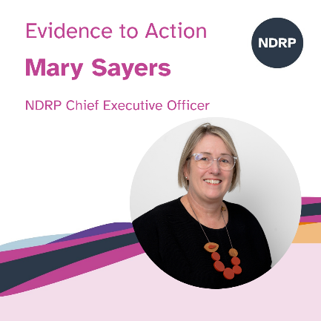
Mary Sayers (NDRP) Event Host: CEO of the National Disability Research Partnership, Mary (she/her) leads NDRP’s mission purpose to fund and support research by and with people with disability that delivers real-world impact. Mary has personal and family experience of disability. She is passionate about ensuring people with lived experience are co-designing services and involved in creating the evidence-base that informs Australian disability policy and practice.

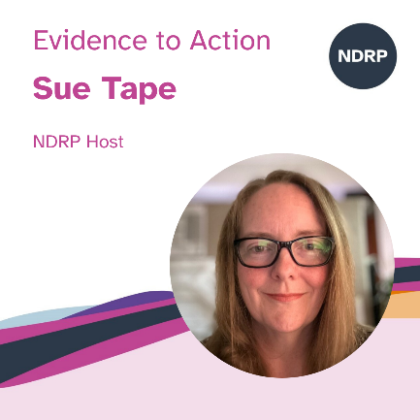
Sue Tape (NDRP) Event Co-Host: Sue (she/her) is the Deputy CEO and Head of Evidence to Action at NDRP, leading efforts to mobilise evidence in ways that genuinely support people with disability, researchers, policymakers and communities. She brings a strong background in advocacy and research translation, informed by her work at Children and Young People with Disability Australia (CYDA) leading inclusive education initiatives. Sue is committed to ensuring disability-led research informs policy and practice, and to building systems that make evidence accessible, practical and meaningful for end users.

Session 2 - Case Study 1: Building better data through partnership
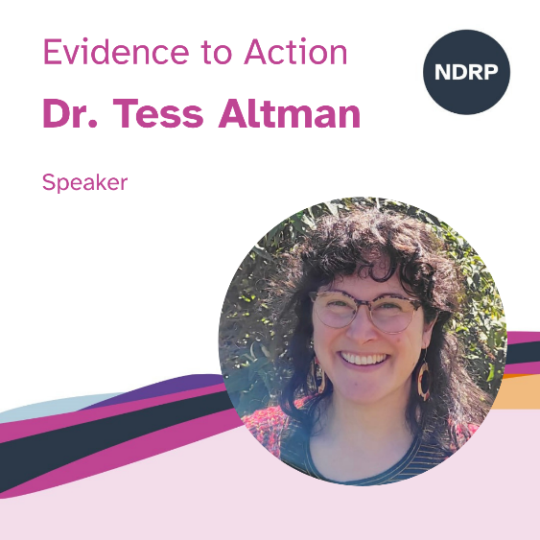
Dr. Tess Altman: Dr Tess Altman (she/her) is Policy and Research Coordinator at Children and Young People with Disability Australia (CYDA) and Senior Researcher at the UNSW Kaldor Centre for International Refugee Law, with over 17 years’ experience across academic, government, and NGO sectors in Australia and internationally. Holding a PhD in Anthropology, Tess has worked with refugee/asylum, youth, disability, LGBTIQA+, multicultural, and First Nations communities. She values (and contributes to) lived experience in research and advocacy.

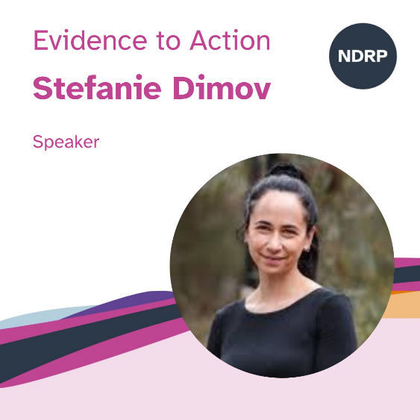
Ms Stefanie Dimov: Stefanie (she/her) is a Research Fellow and PhD candidate at the University of Melbourne, School of Population and Global Health. Her research focuses on disability, employment and youth transitions, particularly in relation to health and wellbeing. She has led and contributed to major studies on disability employment and works closely with young people with disability to co-design research that informs policy and practice.

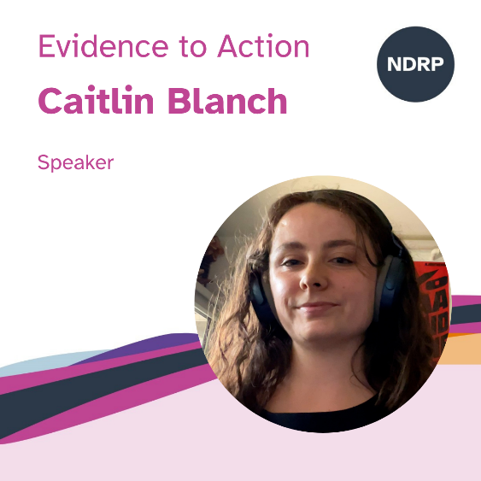
Caitlin Blanch: Caitlin (she/her) is a lived experience contributor who worked as a reviewer on CYDA’s Key Statistics report. She brings her perspective as a person with disability to ensure the data reflects real experiences and is relevant and accessible to the community. Caitlin is passionate about challenging the stereotypes of disability and empowering youth to lead with self-agency and confidence. She is interested in policy/law and advocating for an inclusive and accommodating Australia.

Session 3 – Disability data in the system
- Jennifer Poehl, Director – Outcomes, Data & Community Governance team, Australia’s Disability Strategy Branch, Disability Strategy, Supports and Inclusion Division, Disability and Carers Group, Australian Government Department of Health, Disability and Ageing (DHDA
- Rebecca Hurley, Unit Head, Linkage Client Services, Data Governance & Integration, Corporate Strategy and Performance Division, The Australian Institute of Health and Welfare (AIHW)
- Rachel Price, Director, Program Manager, Data Integration Services Branch, Data & Statistical Practices Group, Australian Bureau of Statistics (ABS)
Session 4 - Case Study 2: Designing data with community
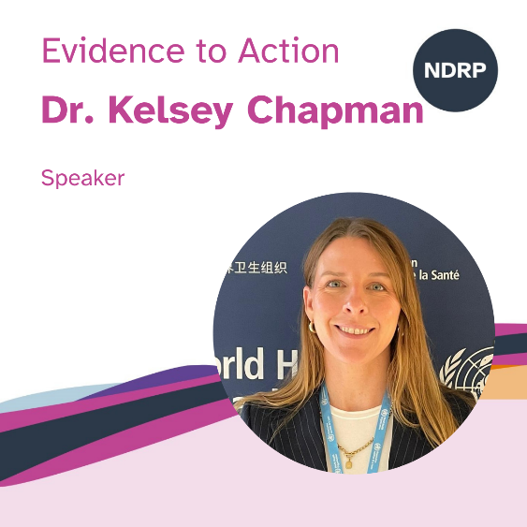
Dr. Kelsey Chapman
Kelsey is an early career researcher and Research Fellow at Griffith University in the Inclusive Futures program. Her work focuses on disability inclusion, health and transport systems, and improving mainstream services for marginalised communities. Her research spans disability policy, service experiences and outcomes, and intersectional equity, including work with First Nations communities. She is committed to ensuring research is not only methodologically strong, but ethically grounded, accessible and impactful.

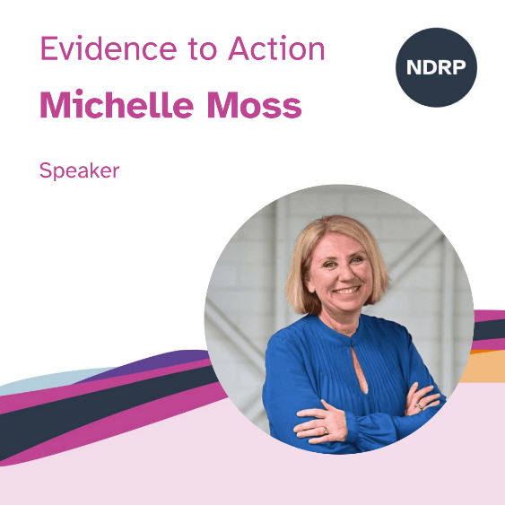
Michelle Moss: Michelle Moss, (she/her), CEO of Queenslanders with Disability Network has worked in the human services sectors for over 30 years, across disability, health, and women’s services including sexual assault and domestic violence services. Michelle has worked in direct support work, counselling, behaviour support, consumer and community engagement, and social policy. Michelle is a strong advocate with a commitment to the voice of people with disability who use services driving and influencing public policy and being active players in the planning, design, delivery and evaluation of services.

Frequently asked questions

What can I do to prepare?
We encourage all attendees to familiarise themselves with key documents before the session:
- The NDRP Research Agenda
- NDRP Guiding Principles
- Do you have question? Submit your question before the session here.

Will the event be recorded?
Yes, all sessions will be recorded and will be made available on the NDRP YouTube channel. At the start of the session, the facilitator will let everyone know that the event is being recorded. If you do not want to be recorded, you can turn off your camera.

What if I have technical difficulties or need help?
We will have support available to assist. You can send a message in the Zoom Chat or Q&A function or email Sue Tape, Head of Evidence to Action who is organising this event at info@ndrp.org.au.

Can I take a break?
Yes, there will be breaks. You are also welcome to take additional breaks whenever you need to. You are welcome to stay in the event during these breaks.

Will there be captioning and Auslan?
Yes, captions and Auslan interpretation will be available during the event. A professional captioner will type what is said for accuracy. To turn captions on or off, click the “More” button (three dots) in the Zoom menu and select “Captions.”

Who will be attending?
Attendees will include people with disability, family members, researchers, policymakers, advocates, service providers, and government representatives.

