What to expect from the Evidence to Action Event

Safety of people with disability

What research and evidence would genuinely shift safety of people with disability in policy and practice and what is currently missing?

Thursday 9 April 2026 | 12:30–2:30pm AEST

Summary 2
The agenda 3
How much will I need to participate in each session? 4
How can I participate in the event? 4
People who will speak 5
Frequently asked questions 7

Summary

About the National Disability Research Partnership
The National Disability Research Partnership (NDRP) funds research led by and with people with disability. Its purpose is to build a national disability research program in Australia that builds evidence for policy and practice to advance the rights of people with disability.
The NDRP wants research to lead to real world solutions. This means working together with people with disability and their organisations, government, service providers, and the community.

Evidence to action
The NDRP holds ‘evidence to action’ events to talk about what is known about a certain topic, what is not known, and what research is needed. The goal of these events is to work together and inform future research and policy directions.

What is this event about
This event is about Safety of people with disability. This sixth event in the Evidence to Action series focuses on preparing for NDRP’s 2026 funding opportunity by providing policy insights, highlighting national priorities, and identifying the critical evidence gaps shaping Safety of people with disability across Australia.
It build on our previous events that explored:
- critical evidence gaps in the accessible and inclusive communities space
- how researchers and advocacy organisations work together in partnership and collaboration in research
- bridging the gap between research and real-world impact, particularly in policy,
- how knowledge mobilisation starts at the beginning of research, not the end, and
- research approaches and opportunities for eliminating restrictive practices.

What you will find in this document
- the agenda for the event on 9 April 2026,
- what is being covered and for how long,
- people who will speak, and
- questions people often ask.

The agenda
9 April 2026 | 12:30–2:30 pm AEST
12:30 pm – Session 1 (15 mins) Setting the scene (low interaction)
- 5 mins: Mary Sayers (CEO of the NDRP), opens the event, welcomes attendees and explains about the event including accessibility features.
- 10 mins: Mary will provide more detail on framing for this event, what evidence is missing and what decision-makers need.
12:45 pm – Session 2 (50 mins) What needs to shift and where research can help - panel discussion (medium interaction)
- 2 mins: Mary Sayers will introduce the panel members and how the panel will run.
- 45 mins: Panel discussion responding to:
  - What kind of research actually influences reform?
  - What do senior policy leaders and regulators need from researchers that they are not currently getting?
- 3 mins: Mary Sayers will provide closing reflections and check in with the audience.
1:35 pm – Screen break (10 mins)
1:45 pm – Session 3 (25 mins) Open forum for questions (high interaction)
- 15 mins: Mary and panellists respond to pre-submitted questions.
- 10 mins: Mary and panellists respond to questions from people in the event
2:10 pm – Session 4 (20 mins) What this means for 2026 applications (medium interaction)
- 10 mins: What this means for applications and resources to help
- 10 mins: Next steps

How much will I need to participate in each session?
The agenda shows the level of interaction for each session. We’ve also included a legend that explains what low, medium, and high interaction mean.
- Low interaction or listen and reflect: Mostly listening. You can reflect quietly or take notes, but no need to contribute in the chat.
- Medium interaction or chat and share: You may be invited to share a thought or question in the chat or the Q&A function. Contribution is optional but welcome.
- High interaction or interactive: You’ll be invited to actively contribute (e.g. type an action into the chat, add a question in the Q&A, respond to prompts, or join discussion). A communication order will be used so you know when it’s your turn and how to contribute.

How can I participate in the event?
We want everyone to feel comfortable participating in a way that suits them during this event.
Here’s how you can engage:
- Ask questions: Use the Chat feature to ask questions at any time. Our facilitators will review and read out questions, during the Q&A session so everyone can hear and engage with the discussion. You can also use the Chat feature to share your thoughts or ideas throughout the session.
- Updating your profile name in Zoom: We encourage you to update your profile name in Zoom to reflect your name and pronouns.
Creating a respectful and inclusive space:
- Avoid using acronyms or jargon. If you do, please explain or spell them out clearly so everyone understands.
- Use and respect people’s preferred pronouns and language, such as "person with disability" or "disabled person."
- Use strengths-based language that promotes respect, understanding, and acceptance.

People who will speak
Session 1 – Setting the scene
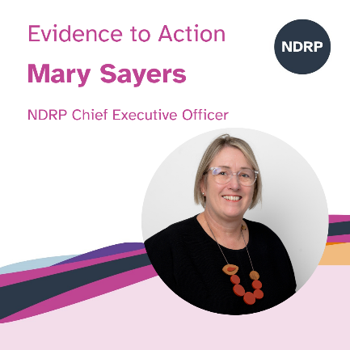
Mary Sayers (NDRP) Event Host: CEO of the National Disability Research Partnership, Mary (she/her) leads NDRP’s mission purpose to fund and support research by and with people with disability that delivers real-world impact. Mary has personal and family experience of disability. She is passionate about ensuring people with lived experience are co-designing services and involved in creating the evidence-base that informs Australian disability policy and practice.

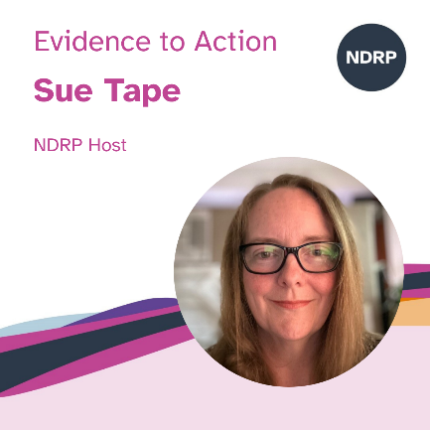
Sue Tape (NDRP Event Co-Host: Sue (she/her) is the Deputy CEO and Head of Evidence to Action at NDRP, where she leads efforts to mobilise evidence in ways that genuinely support people with disability, families, policymakers and communities. She brings a strong background in advocacy and research translation, informed by her work at Children and Young People with Disability Australia (CYDA) leading inclusive education initiatives and supporting families to uphold their child’s right to inclusion. Sue is committed to ensuring disability-led research informs policy and practice, and to building systems that make evidence accessible, practical and meaningful for end users.
Session 2 - What needs to shift and where research can help - panel discussion
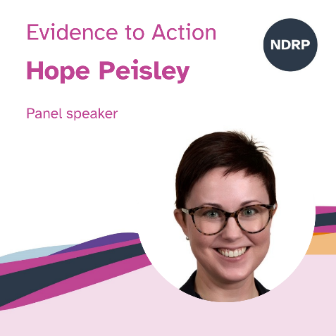
Hope Peisley
Hope Peisley (she/her) is Deputy Director-General, Strategy, Policy and Legislation at the Queensland Department of Families, Seniors, Disability Services and Child Safety. She leads strategic policy development and legislative reform across disability, child safety and community services, with a focus on improving outcomes for Queenslanders and strengthening system accountability.

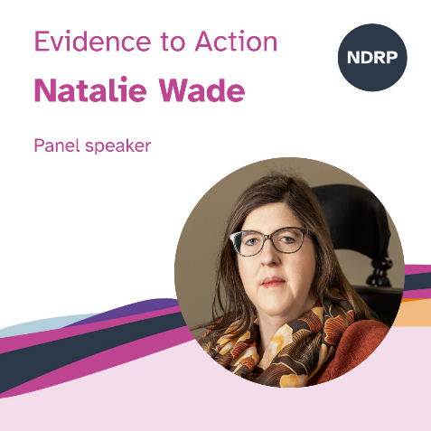
Natalie Wade
Natalie Wade (she/her) is the Associate NDIS Quality and Safeguards Commissioner. Natalie is a pioneer in advancing disability rights committed to driving systemic change and ensuring equality for people with disabilities. In October 2024, she was appointed as the Associate Commissioner of the NDIS Quality and Safeguards Commission. Prior to this, she was the Founder and Principal Lawyer of Equality Lawyers, providing expert legal representation to people with disabilities and their families. In 2023, Ms Wade delivered Australia’s inaugural Disability Leadership Oration with a brief to “set the national agenda”. Her oration focused on ending the segregation of disabled people in all settings, but especially housing, through disabled leadership. Ms Wade is regarded as one of Australia’s foremost disability human rights lawyers and was appointed to lead the first reform to the National Disability Insurance Scheme in response to the NDIS Review, through the NDIS Provider and Worker Registration Taskforce. The taskforce provided 11 recommendations and 10 implementation actions to the Government on a proposed system of regulation for NDIS providers and workers. Ms Wade’s contributions span across law reform and human rights campaigns advancing the rights of women and girls with disabilities, migrants with disabilities and leading advocacy for a Human Rights Act in South Australia. Ms Wade authored Disability Rights in Real Life, a disability rights law handbook for people with disabilities and represented Australia at the United Nations Conference of State Parties to the Convention on the Rights of Persons with Disabilities (16th session). In recognition of her contributions, she was named Australian Young Lawyer of the Year in 2016 and more recently was awarded the 2024 Dennis Mutton Leadership Award.
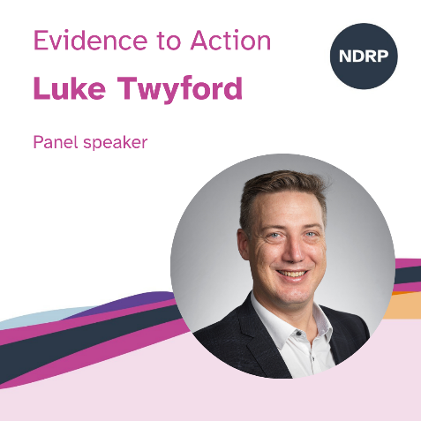
Luke Twyford
Luke Twyford (he/him) joined the QFCC as Chief Executive and Principal Commissioner in January 2022. He is an accomplished senior executive, with rich experience in the child and family sector. Luke’s career spans more than 20 years across Commonwealth, New South Wales and Northern Territory governments in the areas of reform, research and evidence, integrity, audit, governance and complaints management. He has led critical reform of child protection systems and their legal frameworks. He also has extensive experience monitoring the performance of the systems designed to keep children safe and preserve family wellbeing. Luke’s parents fostered a number of children throughout his childhood, with his own lived experience and those of his foster brothers and sisters profoundly shaping the perspectives and passion he brings to his work.

Frequently asked questions

What can I do to prepare?
We encourage all attendees to familiarise themselves with key documents before the session:
- The NDRP 2026 Disability Research Funding information
- The NDRP Research Agenda and in particular, page 20 for accessible and inclusive communities
- NDRP Guiding Principles
- Do you have question? Submit your question before the session here.

Will the event be recorded?
Yes, all sessions will be recorded and will be made available on the NDRP YouTube channel. At the start of the session, the facilitator will let everyone know that the event is being recorded. If you do not want to be recorded, you can turn off your camera.

What if I have technical difficulties or need help?
We will have support available to assist. You can send a message in the Zoom Chat or Q&A function or email Sue Tape, Head of Evidence to Action who is organising this event at info@ndrp.org.au.

Can I take a break?
Yes, there will be breaks. You are also welcome to take additional breaks whenever you need to. You are welcome to stay in the event during these breaks.

Will there be captioning and Auslan?
Yes, captions and Auslan interpretation will be available during the event. A professional captioner will type what is said for accuracy. To turn captions on or off, click the “More” button (three dots) in the Zoom menu and select “Captions.”

Who will be attending?
Attendees will include people with disability, family members, researchers, policymakers, advocates, service providers, and government representatives.

