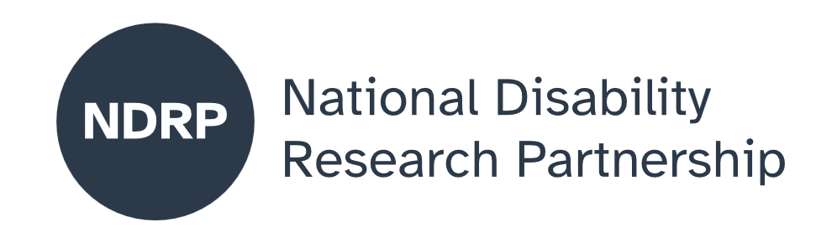


Barriers Within Bars
  - Executive Summary
Plain text version
May 2026

Barriers Within Bars is a national, Indigenous disability led project developed by the BlakAbility team in the Faculty of Arts at the University of Melbourne, in partnership with AccessAble Braille Enterprises, a First Nations disability-led organisation.
Together, these teams bring cultural authority, lived experience and disability expertise to the work. The project examines what is happening to Aboriginal and Torres Strait Islander people with disability in Australian prisons. It was funded as a seed grant through the National Disability Research Partnership in 2024 to begin a wider national conversation and to bring together what is already known about this issue. The project responds to growing concern that Indigenous people with disability are entering and moving through the criminal justice system in ways that reflect systemic failure, not individual circumstances.
Indigenous people with disability experience some of the most significant and preventable forms of injustice in Australia. Their experiences are shaped by the combined effects of racism, ableism, trauma, poverty, gendered inequality and the ongoing impacts of colonisation. These forces influence who is policed, who is refused bail, who is placed
on remand, how people are treated in custody and what supports are available when they return to community. The evidence shows that disability is often unrecognised, misunderstood or punished, and that prison environments are not designed to meet the needs of people with disability. For Indigenous people, these failures are intensified by cultural disconnection, communication barriers and the absence of culturally safe services.
This project matters because it brings visibility to a group that has been largely overlooked in national research and policy. While there is substantial work on Indigenous incarceration and growing work on disability in the justice system, very few studies examine the intersection of the two. This gap has left advocates, families, community organisations and policymakers without the evidence they need to understand what is happening and what must change.

The research team and how representation shaped the work
The project was led by Indigenous researchers with disability, supported by AccessAble Braille Enterprises and a research assistant with lived experience of disability. This leadership structure shaped every stage of the work. It ensured that cultural authority, disability knowledge and lived experience guided the research questions, the interpretation of evidence and the way findings were communicated.
The codesign process brought together Indigenous people with disability, former prisoners, family members, community workers, legal advocates and frontline staff. Their insights shaped the direction of the evidence synthesis, identified gaps in the literature and ensured that the project remained grounded in lived experience. Accessibility was embedded throughout the project, including Easy English materials, alternative formats and the production of Braille versions of key documents.

Key findings
The evidence shows that Indigenous people with disability face significant and preventable barriers before, during and after imprisonment. Key findings include:
- Disability is often unrecognised or misinterpreted, leading to criminalisation rather than support.
- Prison environments are not designed to meet the needs of people with cognitive, psychosocial or physical disability.
- Remand is used extensively, with many Indigenous people held for long periods without conviction.
- Bail laws and procedures do not account for cultural obligations, disability related needs or housing instability.
- Mental health needs are high, yet access to culturally safe and trauma informed care is limited.
- Communication barriers affect safety, participation, decision making and access to justice.
- Family contact is restricted by administrative rules, distance, cost and inconsistent visitation policies.
- Disability supports such as the National Disability Insurance Scheme are withdrawn in custody, disrupting continuity of care.
- Reintegration supports are fragmented, with many people leaving custody without stable housing, health care or disability supports.
- Children and young people with disability are at particular risk, including being held in watch houses or placed in adult forensic settings.
- Many people develop or worsen psychosocial disability during incarceration due to isolation, violence, trauma and lack of support.
These findings reflect systemic failure rather than individual behaviour. They show that the justice system is not meeting its duty of care to Indigenous people with disability and that current practices undermine safety, rights, autonomy and wellbeing.

Major gaps in evidence
The evidence synthesis identified significant gaps that limit national understanding and action. These include:
- Very few studies examine the intersection of Indigeneity and disability in prison settings.
- Limited data on the prevalence of disability among Indigenous prisoners.
- Limited research on the experiences of Indigenous people with cognitive disability, psychosocial disability or acquired brain injury.
- Very little evidence on the experiences of Indigenous women with disability in custody.
- Limited research on the impact of remand, bail refusal and court processes on people with disability.
- Very little research on communication access, including the needs of Deaf, hard of hearing or non speaking Indigenous people.
- Limited evidence on the long term effects of incarceration on disability, mental health and wellbeing.
- Very little research on what works, including culturally grounded, community led programs that support safety and reintegration.
- No national repository of research on Indigenous people with disability in prison settings, making evidence difficult to find and use.
These gaps reflect structural issues, including fragmented research, inconsistent data collection and limited investment in Indigenous disability led research.

Implications for policy and practice
The findings have significant implications for policymakers, practitioners and service providers across justice, disability, health and community sectors. Key implications include:
- Disability identification processes must be improved across policing, courts, corrections and reintegration services.
- Prison health care must be culturally safe, trauma informed and responsive to disability.
- Bail laws and remand practices must be reformed to reduce unnecessary detention and account for disability related needs.
- Communication access must be treated as a human right, with interpreters, support workers and accessible materials available at all stages.
- Disability supports must not be withdrawn in custody, and continuity of care must be guaranteed.
- Reintegration supports must be strengthened, including housing, mental health care, disability supports and cultural connection.
- Children and young people with disability must not be held in unsafe environments such as watch houses or adult forensic units.
- Community controlled organisations must be resourced to lead culturally grounded programs that support healing, connection and reintegration.
- Policymakers must engage directly with Indigenous people with disability to understand barriers and identify solutions.

Recommendations for future research
This seed funded project has highlighted the need for a larger, national study that is Indigenous led, disability led and grounded in lived experience. Priority areas for future research include:
- A national study engaging directly with Indigenous people with disability in custody and post release in every state and territory.
- Research into pathways into the justice system, including child protection, foster care, early exclusion from education and policing practices.
- Research on the experiences of Indigenous women with disability in custody.
- Research on communication access, including the needs of Deaf and hard of hearing Indigenous people.
Website: www.ndrp.org.au Email: info@ndrp.org.au

Accessibility statement
The NDRP is committed to accessible and inclusive communication.
If you need this report in another format – such as Easy English, large print, audio, Auslan, or translated materials, please contact us.

Disclaimer
This publication represents the views of the authors and does not necessarily reflect the views of the National Disability Research Partnership (NDRP) or the Australian Government.
- Evaluation of culturally grounded, community led programs that support safety, healing and reintegration.
- Mapping of political and policy barriers that prevent implementation of pre-existing recommendations.
- Development of a national repository of research on Indigenous people with disability in prison settings.
- Research that identifies practical measures that can be implemented quickly to improve safety and wellbeing.
This Executive Summary reflects the central message of the project. Indigenous people with disability deserve safety, dignity, cultural connection and the right to be supported rather than punished for their disability. Achieving this requires structural reform, sustained investment and a commitment to Indigenous disability leadership at every stage.

Authors
Associate Professor Sheelagh Daniels-Mayes, University of Melbourne Chief Investigator (person with disability); Dr Sharon Kerr, University of Melbourne – Co-researcher; Dr Aunty Roslyn Sackley, Partner Organisation Lead, AccessAble Braille Enterprises (person with disability)

Acknowledgement of funding
This activity received grant funding from the Australian Government as an initiative under Australia’s Disability Strategy 2021–2031, delivered through the National Disability Research Partnership (NDRP).



