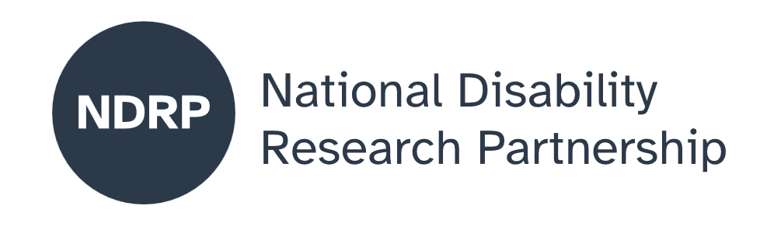
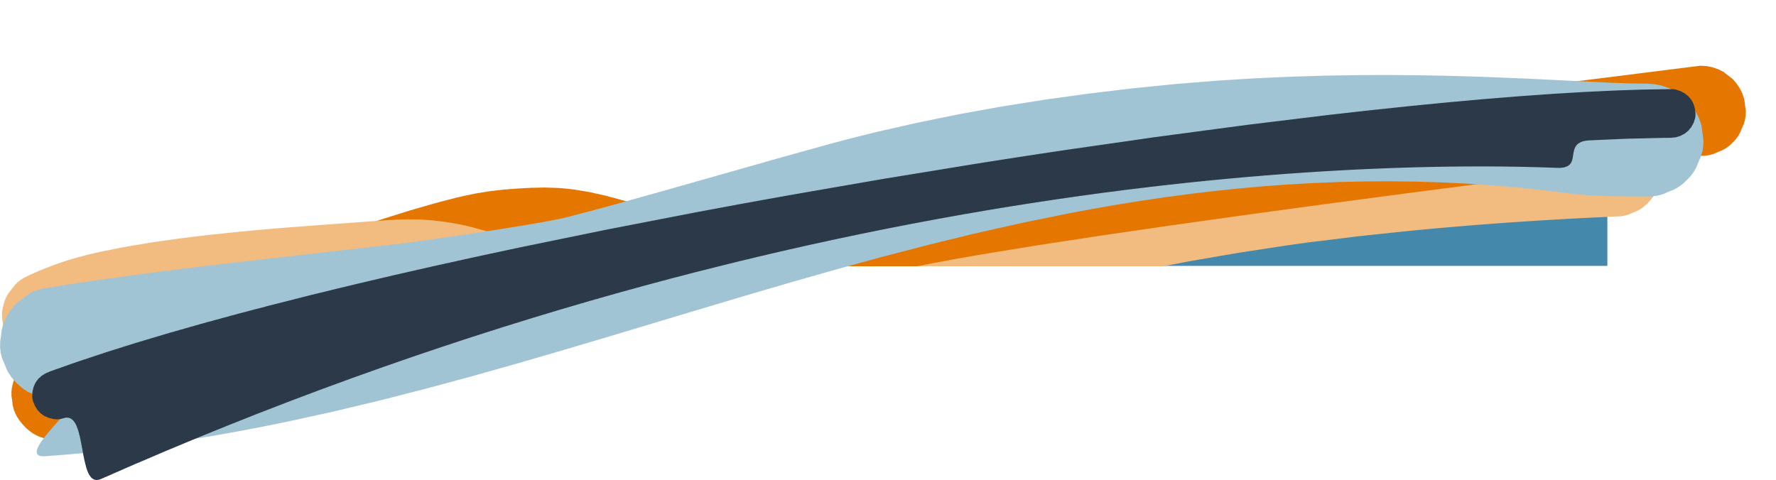

Sometimes I’m too safe. Exploring the dignity of risk with adults with intellectual disability.
  - Project Executive Summary
Rhonda Faragher, Jan Lloyd, Karen Nankervis, Mitchell Toohey, Ruth Faragher
The University of Queensland, Down Syndrome Australia, Down Syndrome and Intellectual Disability Queensland

June 2026

Lead Organisation: The University of Queensland
Partner Organisations: Down Syndrome Australia (DSA) and Down Syndrome and Intellectual Disability Queensland (DSIDQ)

Project team
Full name | Affiliation | Role
Rhonda Faragher | The University of Queensland | Project Lead
Jan Lloyd | The University of Queensland | Project Manager
Karen Nankervis | The University of Queensland | Researcher
Mitchell Toohey | The University of Queensland | Researcher with Down syndrome
Ruth Faragher | The University of Queensland | Researcher with Down syndrome

Period of project activity: 4 August, 2025 – 29 May, 2026
Contact person: Rhonda Faragher

Contributors and acknowledgements
With gratitude, we acknowledge the contribution of our partners, members of the steering committee and our research participants:
- Darryl Steff – DSA CEO and steering committee chair
- Sarah Bone – DSIDQ CEO
- Claire Robinson – DSIDQ, Support Services Officer
- Simone Johnston - Metro South Queensland Department of Health, steering committee
The project enabled the employment of casual research assistants and we acknowledge their contribution to successful outcomes:
- Claire Mitchell, Alana Pettigrew, Callum Scanlon and Mitch Toohey – research assistants with Down syndrome;
- Rachel Aberdine and Natalie Parmenter - research assistants.
In addition, we acknowledge with thanks professional staff of UQ in various teams who have helped with the appointment and support of our research colleagues with Down syndrome.
In the preparation of this report, Microsoft Co-Pilot was used to prepare the first draft of the Executive Summary. Using the University of Queensland’s business subscription to this platform, ensures that uploaded text is not used for machine training or use beyond the university. The final version has been developed by the authors.


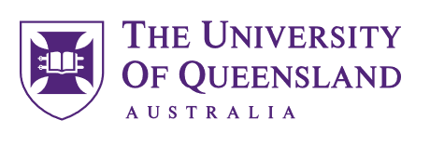
Contents
The issue we explored 4
Why this issue matters 4
What was co-designed 4
What were our key lessons from the co-design process 4
What the future research could achieve 5
What people with disability, policymakers, advocates, services and others need to know about this project 5

When people with intellectual disability are included as leaders and experts, research is stronger, more relevant and more respectful.

How to cite this summary
Faragher, R. M., Lloyd, J., Nankervis, K., Faragher, R., & Toohey, M. (2026). Sometimes I'm Too Safe. Exploring the dignity of risk with adults with intellectual disability. NDRP Final Project Executive Summary. The University of Queensland in partnership with Down Syndrome Australia and Down Syndrome & Intellectual Disability Queensland. Published by the National Disability Research Partnership (NDRP).

The issue we explored
Our work focuses on issues about keeping people with intellectual disability safe while also allowing them to take risks and learn from life experiences. In Australia, families, support workers and services often need to make decisions about how much independence a person should have, but there is very little research or guidance to support these decisions.
The project developed and tested research tools (interviews and surveys) to better understand views of people with intellectual disability—and those who support them—about safety, independence and risk.

Why this issue matters
People with intellectual disability want to make choices, try new things and live meaningful lives. However, when safety is prioritised too strongly by those with a duty of care, it can lead to limited opportunities, reduced independence and fewer chances to learn.
This issue affects many people:
- People with intellectual disability, who want control over their lives
- Families, who want to support the development of autonomy as children grow up
- Support workers, services and police, who have a duty of care
- Policy makers and funders, who want safe and effective systems
Finding the right balance is essential to upholding the rights, dignity and wellbeing of people with disability, in line with Australia’s Disability Strategy.

What was co-designed
This project was co-designed from start to finish with people with intellectual disability working as paid researchers. They helped shape every stage of the work, including:
- Designing the research questions
- Developing, piloting and refining interview questions and surveys
- Conducting pilot interviews with participants
- Reviewing and analysing the data
- Presenting findings and contributing to outputs
The co-design process involved building skills in research, communication and decision-making. It also included practical strategies such as: a Working Agreement developed by the team; check-in and check-outs each work day; and training in research concepts, ethics and interviewing. Importantly, decisions were made together, with lived experience guiding the direction of the research.

What were our key lessons from the co-design process
The co-design process is enhanced by the following principles:
- Ensure people with intellectual disability lead research about their own lives
- Employment of teams is essential, rather than a single individual with the focus disability. This enables collaboration, avoids focusing on one individual’s perspective and minimises power imbalances.

What the future research could achieve
Future research could lead to practical tools, policies and training that help people make better, more informed decisions about risk and independence. Our research would:
- Build better evidence about how to balance safety and autonomy
- Explore differences between what research literature suggests and views of people with intellectual disability
- Provide clear guidance for families, support workers and services
- Improve how support is delivered through the NDIS

What people with disability, policymakers, advocates, services and others need to know about this project
When people with intellectual disability are included as leaders and experts, research is stronger, more relevant and more respectful. This project has developed a research proposal to explore how to support people with intellectual disabilities to take informed risks—not just stay safe—in order to live the life they wish.
Key points from our project are as follows.
- Co-design works best when people with lived experience are employed as equal team members on research projects.
- Building strong teams takes time, training and ongoing support.
- Systems (such as HR and digital platforms) must be accessible and inclusive, especially for employees with intellectual disability.
- Maintain high expectations for all team members, while providing appropriate supports.
- Face-to-face participation is often more effective than online interviews for research with people with intellectual disability.
- Participation of individuals with intellectual disability is enhanced when data collection methods, such as interviews, are led by researchers with intellectual disability.

Authorisation and endorsement
This Project Executive Summary has been reviewed and authorised by:
- Professor Rhonda Faragher, Chief Investigator
- Darryl Steff, Steering Committee Chair, CEO Down Syndrome Australia
- Sarah Bone, CEO Down Syndrome & Intellectual Disability Queensland
- Ruth Faragher, Co-researcher representative, Steering committee member

Disclaimer
This Project Executive Summary represents the views of the project team and does not necessarily reflect the views of the National Disability Research Partnership (NDRP) or the Australian Government.

Acknowledgement of funding
This activity received grant funding from the Australian Government as an initiative under Australia’s Disability Strategy 2021–2031, delivered through the National Disability Research Partnership (NDRP).



