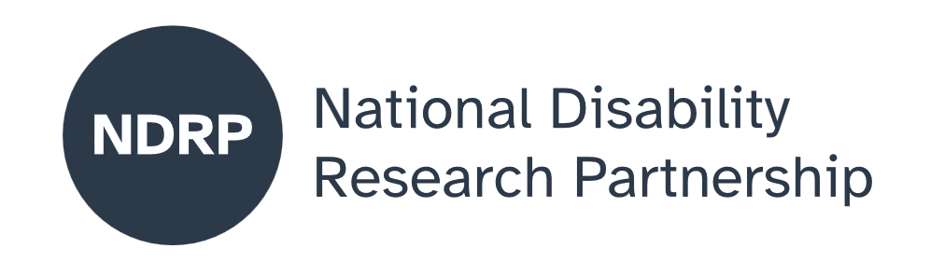


Developing strengths-based and pleasure-centred understandings of sexual safety for neurodivergent women, trans and gender-diverse people in Victoria.
  - Project Executive Summary
Sophie Hindes, Brigid Evans, Jacquiline den Houting, Dr Jessica Ison
The Australian Research Centre in Sex, Health & Society, Women with Disabilities Victoria, Olga Tennison Autism Research Centre, ReGEN

June 2026

Lead Organisation: Australian Research Centre in Sex, Health and Society, La Trobe University
Partner Organisations: Women with Disabilities Victoria; Olga Tennison Autism Research Centre, La Trobe University; La Trobe’s Reducing Gender-Based Violence Research Group

Project team:
Full name | Affiliation | Role
Sophie Hindes | Australian Research Centre in Sex, Health and Society, La Trobe University | Project Lead
Lily Moor | Australian Research Centre in Sex, Health and Society, La Trobe University | Project Manager
Lena Molnar | Women with Disabilities Victoria | Chief Investigator
Melissa Jolley | Women with Disabilities Victoria | Project Officer
Natalie Amos | Australian Research Centre in Sex, Health and Society, La Trobe University | Chief Investigator
Adam Bourne | Australian Research Centre in Sex, Health and Society, La Trobe University | Chief Investigator
Jax Brown | Australian Research Centre in Sex, Health and Society, La Trobe University | Chief Investigator and Co-Design Facilitator
Lukas Burgess | Australian Research Centre in Sex, Health and Society, La Trobe University | Lived Experience Researcher
Jacquiline den Houting | Olga Tennison Autism Research Centre, La Trobe University | Chief Investigator
Brigid Evans | Women with Disabilities Victoria | Chief Investigator
Jessica Ison | La Trobe’s Reducing Gender-Based Violence Research Group, La Trobe University, | Chief Investigator
Emma Jago | Australian Research Centre in Sex, Health and Society, La Trobe University | Lived Experience Researcher
Zoe Simmons | Australian Research Centre in Sex, Health and Society, La Trobe University | Lived Experience Researcher
Sarah Vrankovich | Australian Research Centre in Sex, Health and Society, La Trobe University | Chief Investigator

Period of project activity: July 2025-May 2026
Contact person: Sophie Hindes, s.hindes@latrobe.edu.au

Content notes
This report discusses sexual safety, sexual violence, and barriers to support experienced by neurodivergent women, trans and gender-diverse people. It includes content related to sexual harm, systemic exclusion, and discrimination in health, education, and service systems. The report also uses strengths-based and affirming language about disability, gender, and sexuality.
If you need support at any time, you can contact:
- 1800RESPECT (Australia’s national sexual assault, domestic and family violence counselling service): 1800 737 732 or https://www.1800respect.org.au
- Lifeline (24/7 crisis support): 13 11 14 or https://www.lifeline.org.au
- QLife (LGBTIQ+ peer support and referral service): 1800 184 527 or https://qlife.org.au

Contributors and acknowledgements
This project was co-designed and delivered through collaboration between lived experience researchers, community partners, and academic researchers over a nine-month period – all of whom are listed above.
We acknowledge and thank all members of the research team who shared their lived experience as part of the project, in particular, the lived experience researchers whose insights and expertise were central to shaping the research agenda and co-design process. We also acknowledge partner organisations who supported project governance, recruitment, evaluation, and knowledge sharing across the project.
AI was used in the preparation of this report to assist with plain language requirements.




Contents
The issue we explored 5
Why this issue matters 5
What was co-designed 5
What were our key lessons from the co-design process 6
What the future research could achieve 6
What people with disability, policymakers, advocates, services and others need to know about this project 6

…for neurodivergent women, trans and gender-diverse people, sexual safety is not only about avoiding harm but also about being able to access positive, affirming, and self-determined sexual lives.

How to cite this summary
Hindes, S., Moor, L., Molnar, L., Jolley, M., Amos, N., Bourne, A., Brown, J., Burgess, L., den Houting, J., Evans, B., Ison, J., Jago, E., Simmons, Z., & Vrankovich, S. (2026). Developing strengths-based and pleasure-centred understandings of sexual safety for neurodivergent women, trans and gender-diverse people in Victoria. NDRP Final Project Executive Summary. (Partner organisations: Australian Research Centre in Sex, Health and Society, La Trobe University; Women with Disabilities Victoria; Olga Tennison Autism Research Centre, La Trobe University; La Trobe’s Reducing Gender-Based Violence Research Group). Published by the National Disability Research Partnership (NDRP).

The issue we explored
This project brought together lived experience researchers, community partners, and academic researchers over nine months to co-design a research proposal focused on sexual safety for neurodivergent women, trans and gender-diverse people in Victoria.
The project took a strengths-based approach, centring pleasure, agency, and sexual wellbeing, rather than focusing only on risk and harm. We developed research questions and methods that are designed to understand how neurodivergent women, and trans and gender-diverse people experience, define, and negotiate sexual safety in their everyday lives from a strengths-based perspective.

Why this issue matters
Much existing research and policy frames sexual safety for neurodivergent women, and trans and gender-diverse people through risk and harm, overlooking how people manage safety, relationships, and pleasure in everyday life. While there is strong evidence that these groups experience higher rates of sexual violence and face significant barriers to support, these barriers are often shaped by systems that are not inclusive or affirming, and by ableist assumptions that neurodivergent or disabled people are deviant or are not sexual, limiting recognition of sexual agency and rights.
Neurodivergent people also often receive limited or incomplete sex education, particularly in school-based segregated settings, with knowledge gaps evident in areas such as consent, communication, diverse relationships, and sexual practices. Emerging work is calling for disability-affirming, trauma-informed, and pleasure-centred approaches to sexual safety that foreground sexual agency and wellbeing.

What was co-designed
Through a nine-month co-design process, we developed a research proposal that reframes sexual safety using a strengths-based and pleasure-centred approach. The co-design process involved lived experience researchers, community partners, and academic researchers working collaboratively across all stages of the project.
Together, we co-designed:
- A research approach grounded in lived experience leadership.
- Key concepts for understanding sexual safety beyond risk and harm.
- Research questions that centre pleasure, agency, communication, and wellbeing.
- Ethical and qualitative methodological approaches for working with neurodivergent women, trans and gender-diverse communities.
- Recommendations for future co-design with neurodivergent communities.

What were our key lessons from the co-design process
- Co-design needs time, structure, and clear processes to support fair and meaningful participation.
- Inclusive, values-led leadership and skilled facilitation are essential for safety, access, and engagement.
- Inclusion must be intentionally designed and resourced, including flexibility, accessibility, and attention to cognitive load.
- Valuing and balancing the importance of both lived experience and professional expertise builds trust and strengthens collaboration.
- Strong partnerships and relationship-building add value but require adequate funding, time, and care.
- Dedicated funding is essential to centre lived experience and enable genuine co-design.

What the future research could achieve
The co-designed research proposal provides a foundation for developing new ways of understanding and supporting sexual safety that are inclusive of pleasure, agency, and diversity.
Future research could:
- Build evidence on what sexual wellbeing and safety look like for neurodivergent women, trans and gender-diverse communities.
- Inform the development of inclusive sexual health education and resources.
- Improve service responses in health, education, and support settings.
- Contribute to policy frameworks that move beyond risk-only approaches.
- Support more affirming, accessible, and rights-based understandings of sexuality.

What people with disability, policymakers, advocates, services and others need to know about this project
This project highlights that for neurodivergent women, trans and gender-diverse people, sexual safety is not only about avoiding harm but also about being able to access positive, affirming, and self-determined sexual lives.
However, there is still limited research in this area, meaning we know little about the barriers and enablers to affirming sexual experiences for this cohort. More research is needed, and it must be adequately funded and co-designed with lived experience expertise to ensure it reflects people’s realities and priorities, and produces knowledge that is both relevant and useful for policy and practice.

Authorisation and endorsement
This Project Executive Summary has been reviewed and authorised by:
- Sophie Hindes, Chief Investigator, The Australian Research Centre in Sex, Health & Society
- Brigid Evans, Women with Disabilities Victoria, Partner Organisation Lead
- Jacquiline den Houting, Olga Tennison Autism Research Centre, Partner Organisation Lead
- Dr Jessica Ison, ReGEN, Partner Organisation Lead

Disclaimer
This Project Executive Summary represents the views of the project team and does not necessarily reflect the views of the National Disability Research Partnership (NDRP) or the Australian Government.

Acknowledgement of funding
This activity received grant funding from the Australian Government as an initiative under Australia’s Disability Strategy 2021–2031, delivered through the National Disability Research Partnership (NDRP).



