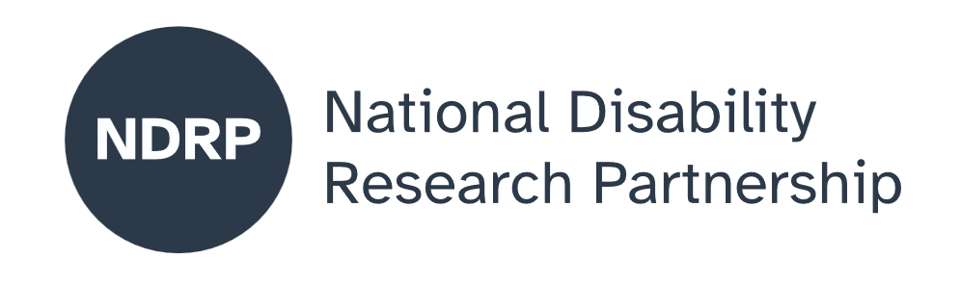
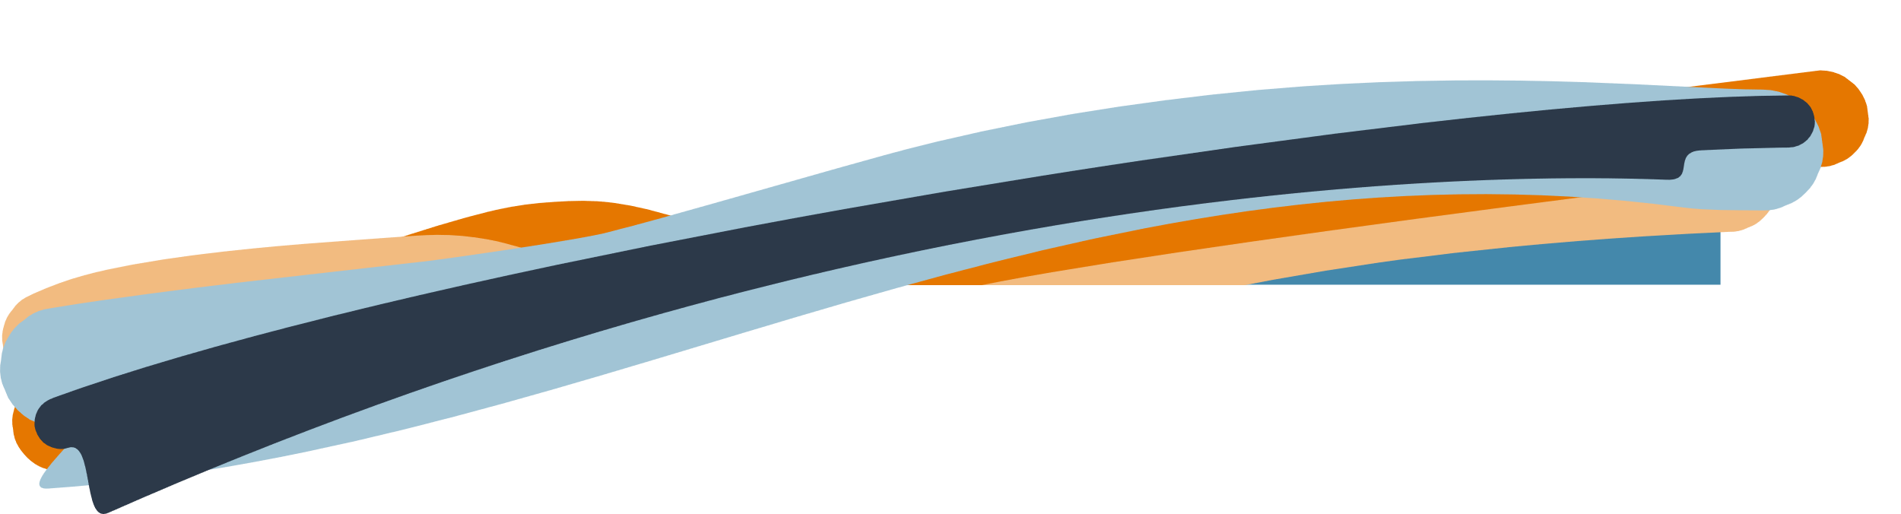
  - Cultivating Safety in Agriculture for Persons with Disability
  - Project Executive Summary
Josie Clarke, Nicole McDonald, Pat Colusso, Nigel Corish
Ability Agriculture Foundation and CQUniversity

March 2026

Lead organisation: Ability Agriculture Foundation
Partner organisations CQUniversity

Project team
- Josie Clarke – Ability Agriculture Foundation - Project Lead, Chief Investigator
- Nicole McDonald – CQUniversity – Co-researcher
- Pat Colusso – CQUniversity – Co-researcher
- Nigel Corish – Ability Agriculture Foundation – Co-researcher
Period of project activity: 6 months
Contact person: Josie Clarke

Content notes

This report discusses experiences related to workplace safety, disability, injury risk, discrimination, fear of disclosure, and systemic barriers to safe participation in work. Some readers may find these topics confronting or distressing. The content is presented to support understanding, learning, and systems improvement, and does not include graphic descriptions. Readers are encouraged to take breaks or seek support if needed while engaging with this material. Information about accessibility supports and alternative formats is provided at the end of this report.

Agriculture based support
- Rural Aid provides free counselling for farmers, agricultural workers, and their families, delivered by counsellors with rural and farming experience (phone, telehealth, or on farm). Phone: 1300 175 594 ruralaid.org.au
- TIACS (This Is A Conversation Starter) offers free phone and text counselling for people working in blue collar industries, including agriculture. Phone or text: 0488 846 988

Disability and general mental health support
- Beyond Blue provides free, confidential 24/7 counselling by phone or online chat for anyone experiencing distress, anxiety, or depression. Phone: 1300 22 4636 beyondblue.org.au
- Disability Gateway is a free national service that helps people with disability find counselling, advocacy, and local supports. Phone: 1800 643 787 health.gov.au

Contributors and acknowledgements
We’d like to acknowledge the involvement and support of this project: Our research participants for their lived experiences, knowledge and problem-solving to address a topic that within agriculture has previously not been visible, but is vital to ensuring progress, safety and meaningful participation in agricultural work and on farm environments.
Use of AI statement
AI Microsoft co-pilot was utilised to summarise key insights from in-depth analyses. AI was not utilised in data analysis.
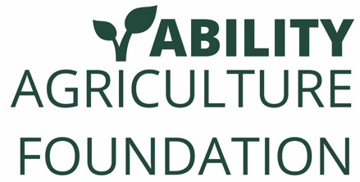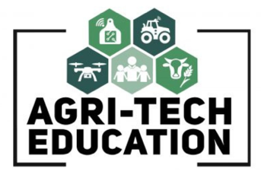
Contents

The issue we explored 4
Why this issue matters 4
What was co-designed 4
What were our key lessons from the co-design process 5
What the future research could achieve 6
What people with disability, policymakers, advocates, services and others need to know about this project 7

Knowledge gaps create risk. When people are unsure where to get help, who is responsible, or what supports exist, safety decisions are delayed or avoided.

How to cite this summary
Clarke, J., Colusso, P., Corish, N., & McDonald, N. (2026). Cultivating Safety in Agriculture for Persons with Disability. Ability Agriculture, CQUniversity and National Disability Research Partnership. Project Executive Summary. Published by the National Disability Research Partnership (NDRP).

The issue we explored
People with disability already live, work, and contribute across Australia’s agricultural sector. However, farm safety systems, employment pathways, and workplace practices rarely consider disability in a practical, intentional, or joined up way. As a result, people with disability often face increased safety risks, uncertainty about adjustments and safety compliance, pressure to hide their disability, or exclusion from work altogether.
Ability Agriculture has already identified that agricultural employer disability confidence is a factor that may be limiting employment opportunities for people with disability. While past research has shown that employers need to “rethink the role of people with disabilities in the workforce” (Winn & Hay, 2009, p. 103), it has also demonstrated the complications of transitioning people with a disability into employment as a range of services designed to support this can be involved and this can differ from employment contexts in metropolitan areas (Willsher, 2015; Gilroy et al., 2023). Furthermore, gaps exist in the literature that seeks to understand issues that impact or relate to farm safety for people with disability. For example, a recent search utilising the keywords (disability or disabilities or disabled) AND farm safety within EBSCOhost database for academic journal articles from the last 10 years, returned no relevant results from an Australian context. The ecosystem that supports safe work experiences for people with disability in farming and agriculture requires further investigation.
This project explored how the agricultural safety ecosystem currently supports—or fails to support—safe participation for people with disability, and what changes are needed to make agricultural workplaces safer, fairer, and more inclusive.
Rather than focusing solely on individual workers perspectives, this project examined the whole ecosystem: people with lived experience working in agriculture, employers, farm safety professionals, occupational therapists and allied health practitioners, agribusiness, and broader support systems including education and training specialists.

Why this issue matters

Agricultural enterprises are a major employer in rural and regional communities and offers meaningful, skilled, and diverse work. However, it also remains one of Australia’s most dangerous industries (Safe Work Australia, 2023).

Within our scoping research we found that for people with disability, the stakes are high:
- Feeling unsafe or unsupported at work can lead to injury, withdrawal from employment, or exclusion from the sector.
- Many people with disability report pressure to “push through”, avoid disclosure, or rely on unsafe workarounds to stay employed.
- Employers often want to be inclusive but feel unsure where to start, worry about risk and insurance, or lack access to clear, practical guidance.
- Current farm safety approaches tend to rely on a narrow “fitness for work” lens, placing responsibility on the individual worker rather than on systems, task design, and shared responsibility.

Importantly, the project found that inclusive safety practices lift overall work conditions in ways that benefit everyone. When workplaces are safer and more flexible for people with disability, communication improves, teams collaborate better, and overall safety culture is strengthened.

What was co-designed
This project used a disability-led, codesign approach. People with lived experience of disability in agriculture, ranging from young persons working in agricultural enterprises, farm owners and self-employed farmers across rural and remote farming enterprises from grains, beef, sheep, dairy horticulture and agricultural research sectors were involved throughout, alongside employers, safety experts, and allied health professionals.
Key activities included:
- In-depth interviews across multiple states
- Thematic analysis of lived experience, employer, safety, and allied health perspectives
- Development of a prototype ecosystem map showing how decisions, knowledge gaps, supports, and pressures affect safety outcomes
- Roundtable sessions to ground truth findings, test assumptions, and prioritise solutions
Together, participants co-designed a “Cultivating Safety” ecosystem framework, identifying:
- Who influences safe work for people with disability on farms
- How safety decisions are actually made in real settings
- Where risks increase due to knowledge gaps, system pressures, or informal workarounds
- Where opportunity exists for changes to the ecosystem that are most feasible and impactful in the short and medium term
The work identified three common participation pathways for people with disability in agriculture:
- Open employment with limited support, knowledge and informal adjustments (higher risk)
- Open employment or self-employment with informed supports and collaboration (enabling)
- Family farm or self-employment with informal adjustments (variable safety)
A prototype of the Farm Safety For People with Disability ecosystem was mapped with 15 roundtable participants who represented persons with disability working in agriculture, agribusiness professionals, farm safety experts and OT/Allied Health persons. While significant diversity exists amongst farming enterprises, two potential models (one for people with disability within a farming family, and one for people with disability in other farming enterprises) were developed.
The ecosystem identifies:
- Who influences safe employment for people with disability on farm
- How different agents interact to improve outcomes for people with disability on farm
- What enabling factors exist for groups in influencing safe employment
- What challenges persist that inhibit the functionality of the ecosystem
Persons with lived experience in agriculture, OT and allied health professionals, agribusiness and farm employers and Farm Safety experts were involved in identifying key priority areas, short term, long-term and practical solutions to address farm safety agriculture for persons with disability. This was a co-designed ecosystem approach to inform and prioritise future research projects and inform practical program development.

What were our key lessons from the co-design process

Several clear lessons emerged across all participant groups through the co-design process, which brought together diverse perspectives and created space for shared learning and reflection:
- Knowledge gaps create risk. When people are unsure where to get help, who is responsible, or what supports exist, safety decisions are delayed or avoided.
- Confidence drives safety. Confidence to ask questions, disclose needs, and have honest conversations strongly influences safety outcomes.
- Informal problem-solving can help - but can also harm. Agriculture’s “DIY” culture and lack of access to funding and support, encourages adaptation but can normalise unsafe practices. Our co-design discussion identified opportunity to capitalise on employers and on-farm teams, and family farms willingness to take action to provide 'work arounds' and improve informal safety adjustments by enhancing how knowledge and practice flows through the ecosystem.
- System navigation must be shared. Workers, employers, safety consultants, and allied health professionals often assume others are responsible for adjustments, creating gaps in safety for people with disability in agricultural workplaces.
- Inclusion improves safety for everyone. Employers reported stronger teams, better communication, and improved safety culture when inclusive practices were adopted.
Importantly, the co-design methodology itself demonstrated significant value beyond the findings. Bringing together individuals with lived experience alongside system stakeholders enabled deeper understanding, grounded discussions, and more practical, context-specific solutions. Diverse experiences and expertise contributed to stronger insights and more meaningful potential outcomes for the system.
The process fostered open, constructive conversations and, for many participants, created the first dedicated space within agriculture to explore these issues collectively. In a sector often shaped by isolation and the tyranny of distance, co-design also played an important role in connection; enabling participants to feel less isolated and more united in shared values around improving work experiences and inclusion in agriculture.
Participants demonstrated strong engagement beyond the formal process, making time to stay involved, remain informed, and contribute to future directions. There was a clear interest in seeing their contributions translated into action, reflecting a sense of shared ownership and commitment to change. By utilising co-design, the project avoided the “extraction” of participant stories and instead remained grounded in its purpose of working collaboratively towards transformational change.
This approach is particularly important in agriculture. As an industry shaped by independent decision-making and entrepreneurial approaches, meaningful and sustained change requires broad buy-in from a diverse range of people. Co-design supports this by building trust, shared understanding, and collective responsibility.
Overall, the process reinforced the importance of psychological safety and clear guidance; ensuring people feel confident to seek support, contribute openly, and engage in conversations without fear of stigma, judgement, or negative consequences.

What the future research could achieve
Building on this foundation, future research could move from exploration to action by:
- Co-designing practical tools such as task–ability mapping guides and workplace adjustment resources tailored to farming contexts
- Developing training for supervisors and employers to build disability confidence and inclusive safety skills
- Strengthening connections between agriculture, safety, and allied health systems so people do not fall through gaps
- Strengthen informal supports for safer outcomes
- Testing and evaluating these tools on farms to understand what works, for whom, and in what conditions
- Identifying areas for systems-level intervention, including advocacy for change at the policy level
- This next phase has strong potential to deliver measurable improvements in safety, workforce participation, and inclusion, while reducing reliance on or empowering informal practices to have safer outcomes.

What people with disability, policymakers, advocates, services and others need to know about this project
- People with disability are already part of Australian agriculture and want to work safely and sustainably.
- Exclusion is not inevitable; risk can be managed through better design, communication, and systems, not by removing people from work.
- Employers need clear, practical guidance, not abstract policy or compliance checklists.
- Safety should be a shared responsibility, embedded into everyday farm practice.
- Disability inclusive safety is not an “add-on”; it strengthens agriculture’s future workforce, culture, and sustainability.
Safe work for people with disability in agriculture is achievable. It requires confidence, clarity, collaboration, and practical tools, not perfection. By strengthening the ecosystem around people, farms can create safer, fairer workplaces where everyone can contribute and get home safely.

References
Ability Agriculture Foundation, & Rimfire Resources. (2024). Supported employment in agriculture: An independent report (Independent report). Ability Agriculture Foundation.
Australian Government. (2021). Australia’s disability strategy 2021–2031.
https://www.disabilitygateway.gov.au/australias-disability-strategy
Australian Human Rights Commission. (2016). Willing to work: National inquiry into employment discrimination against older Australians and Australians with disability.
https://humanrights.gov.au/our-work/disability-rights/publications/willing-work
Gilroy, J., Veli‐Gold, S., Wright, W., Dew, A., Jensen, H., Bulkeley, K., & Lincoln, M. (2023). Disability workforce and the NDIS planning process in regional, rural and remote regions of Australia: Scoping review. Australian Journal of Rural Health, 31(5), 839-854.
National Disability Insurance Agency. (2023). Employment and workplace supports.https://www.ndis.gov.au/participants/working-and-studying
Safe Work Australia. (2023). Work-related injuries in agriculture. https://www.safeworkaustralia.gov.au
Willsher, K. A. (2015). Disability in rural areas of Australia: an opportunity to develop community resources. The International Journal of Community Diversity, 14(4), 1.
Winn, S., & Hay, I. (2009). Transition from school for youths with a disability: issues and challenges. Disability & Society, 24(1), 103–115. https://doi.org/10.1080/09687590802535725

Authorisation and endorsement
This Project Executive Summary has been reviewed and authorised by:
- Josie Clarke, Chief Investigator
- Nicole McDonald, Partner Organisation Lead

Disclaimer
This Project Executive Summary represents the views of the project team and does not necessarily reflect the views of the National Disability Research Partnership (NDRP) or the Australian Government.

Acknowledgement of funding
This activity received grant funding from the Australian Government as an initiative under Australia’s Disability Strategy 2021–2031, delivered through the National Disability Research Partnership (NDRP).


