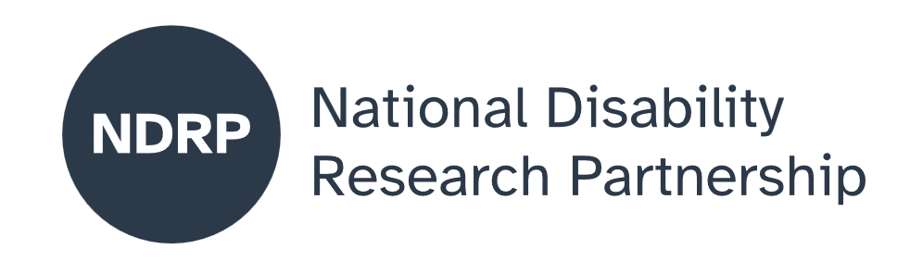

  - Psychological Safety of Children with Disability Labelled with ‘Behaviours of Concern’
  - Project Executive Summary
A/Prof Sarah Knight, Dr Nicole Merrick, Prof Christine Imms, A/Prof Matt Harrisons, A/Prof Lisa McKay-Brown, Chelsea Aquilina, Heather Renton, Juanita Mulholland, Cat Lancaster, Kate Heine, Natasha Staheli, Katie Koullas
University of Melbourne, Yellow Ladybugs, Heads Together for Brain Injury

April 2026

Lead organisation: University of Melbourne
Partner organisations: Yellow Ladybugs, Heads Together for Brain Injury

Project team
- A/Prof Sarah Knight, Project Lead and Investigator
- Dr Nicole Merrick, Project Co-lead and Investigator
- Prof Christine Imms, Investigator
- A/Prof Matt Harrisons, Investigator
- A/Prof Lisa McKay-Brown, Investigator
- Chelsea Aquilina, Lived Experience Investigator
- Heather Renton, Lived Experience Investigator
- Juanita Mulholland, Lived Experience Investigator
- Cat Lancaster, Investigator
- Kate Heine, Partner Organisation Lead (Heads Together for Brain Injury)
- Natasha Staheli, Partner Organisation Lead (Yellow Ladybugs)
- Katie Koullas, Partner Organisation Lead (Yellow Ladybugs)

Period of project activity: August 2025 to April 2026
Contact person: A/Prof Sarah Knight, sarah.knight@unimelb.edu.au

Content notes

This report discusses school-based distress, restrictive practices, bullying, self-harm and suicidal thoughts. If you are affected by these topics, you may wish to seek support from a trusted person or a professional support service.

Contributors and acknowledgements
We gratefully acknowledge the leadership and expertise of our Lived Experience Investigators and partner organisations throughout this project. We also acknowledge all workshop participants (young people with disability, family members, educators, clinicians and researchers) who shared their time and insights to co-design the future research proposal.
Acknowledgement of funding: This activity received grant funding from the Australian Government as an initiative under Australia’s Disability Strategy 2021–2031, delivered through the National Disability Research Partnership (NDRP). Funding also supported Lived Experience Investigator and Chief Investigator travel to and attendance at Australia’s National Disability Strategy 2021–2031 summit in Adelaide, February 2026.
Use of AI tools: AI tools were used to assist with editing for clarity and Plain English, with all content reviewed and approved by the project team.

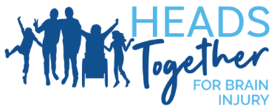

Contents

The issue we explored 4
Why this issue matters 4
What was co-designed 4
What were our key lessons from the co-design process 4
What the future research could achieve 4
What people with disability, policymakers, advocates, services and others need to know about this project 5

People with disability and families have been clear that many current behaviour approaches feel unsafe, create shaming, and can be traumatising. Young people exposed to these approaches often feel that their rights and autonomy are not respected.

How to cite this summary
Knight, S., Merrick, N., Imms, C., Harrison, M., McKay-Brown, L., Aquilina, C., Renton, H., Mulholland, J., Lancaster, C., Heine, K., Staheli, N., & Koullas, K. (2026). Psychological safety of children with disability labelled with ‘behaviours of concern’. Project Executive Summary. Published by the National Disability Research Partnership (NDRP).

The issue we explored
This project focused on the psychological safety of children and young people with disability who are labelled as having “behaviours of concern”.
Instead of being understood and supported, often these children are punished, restrained, or excluded from class and school activities; experience bullying and stigma; are seen as “the problem” rather than as children communicating their needs.
This project is about planning future research that will directly address how to make school environments feel psychologically safer and more inclusive for children with disability.

Why this issue matters

People with disability and families have been clear that many current behaviour approaches feel unsafe, create shaming, and can be traumatising. Young people exposed to these approaches often feel that their rights and autonomy are not respected.

This project matters because it centres the voices of people with disability who have lived experience of this issue. This project shifts the focus from “fixing the child” to ensuring psychological safety, dignity, and rights are maintained. Further, the project explores the experience of psychological safety and the triggers in the environment that might lead to an experience of “behaviours of concern.”

What was co-designed
This project co-designed a future research proposal with young people with disability and parents/caregivers. Together, we agreed the key research questions, shaped a rights-based and trauma-informed study design, and developed practical ways of working that support inclusive, psychologically safe co-design.

What were our key lessons from the co-design process
- Start by building relationships and trust.
- Co-design ‘safety rules’ (breaks, communication, sensory needs, and how to handle distress).
- Use plain language and shared definitions for key terms.
- Make decisions through respectful discussion and shared power.
- Plan for changing capacity and offer flexible ways to contribute.
- Evaluate the co-design process, not just the outputs, and share what you learn.

What the future research could achieve
Future research developed from this project can:
- Improve understanding of what psychological safety means for young people with disability, in their own words.
- Shift practice from focusing on “fixing the child” to changing environments, relationships, and supports so children feel safe and respected.
- Reduce harm from restrictive practices, exclusion, and punishment in schools.
- Support rights-based, trauma-informed practice, aligned with Australia’s National Disability Strategy 2021-2031, the National Autism Strategy, and human rights framework.
- Give decision-makers clear guidance on what works, what causes harm, and what needs to change in policies and systems.
- Build capacity and leadership of young people with disability as research partners and experts.
- Develop a series of recommendations on creating psychologically safe school environments with young people with disability.

What people with disability, policymakers, advocates, services and others need to know about this project
- Behaviour is communication and policy and practice must start from this understanding, rather than from control or punishment.
- Psychological safety is a right, not a “nice to have” and children with disability have the right to feel safe, respected, and included.
- The child is not the problem and support should focus on changing environments, attitudes, and adjustments rather than trying to “fix” the child.
- Trauma-informed, rights-based approaches must replace harmful, restrictive and exclusionary practices.
- People with disability must lead and shape solutions to create meaningful change.
- Inclusive co-design is possible and powerful and ensures all voices are heard.
Together, these messages call for a shift away from deficit-based views of behaviour and towards a system that listens to, values, and protects the psychological safety of children with disability.

Authorisation and endorsement
This Project Executive Summary has been reviewed and authorised by:
- A/Prof Sarah Knight, Chief Investigator
- Natasha Staheli, Partner Organisation Lead (Yellow Ladybugs)
- Kate Heine, Partner Organisation Lead (Heads Together for Brain Injury)

Disclaimer
This Project Executive Summary represents the views of the project team and does not necessarily reflect the views of the National Disability Research Partnership (NDRP) or the Australian Government.

Acknowledgement of funding
This activity received grant funding from the Australian Government as an initiative under Australia’s Disability Strategy 2021–2031, delivered through the National Disability Research Partnership (NDRP).


