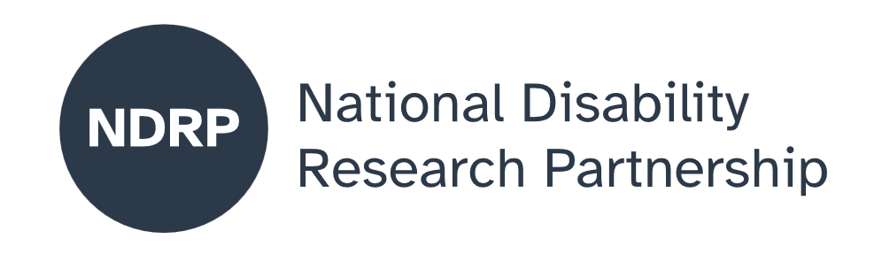
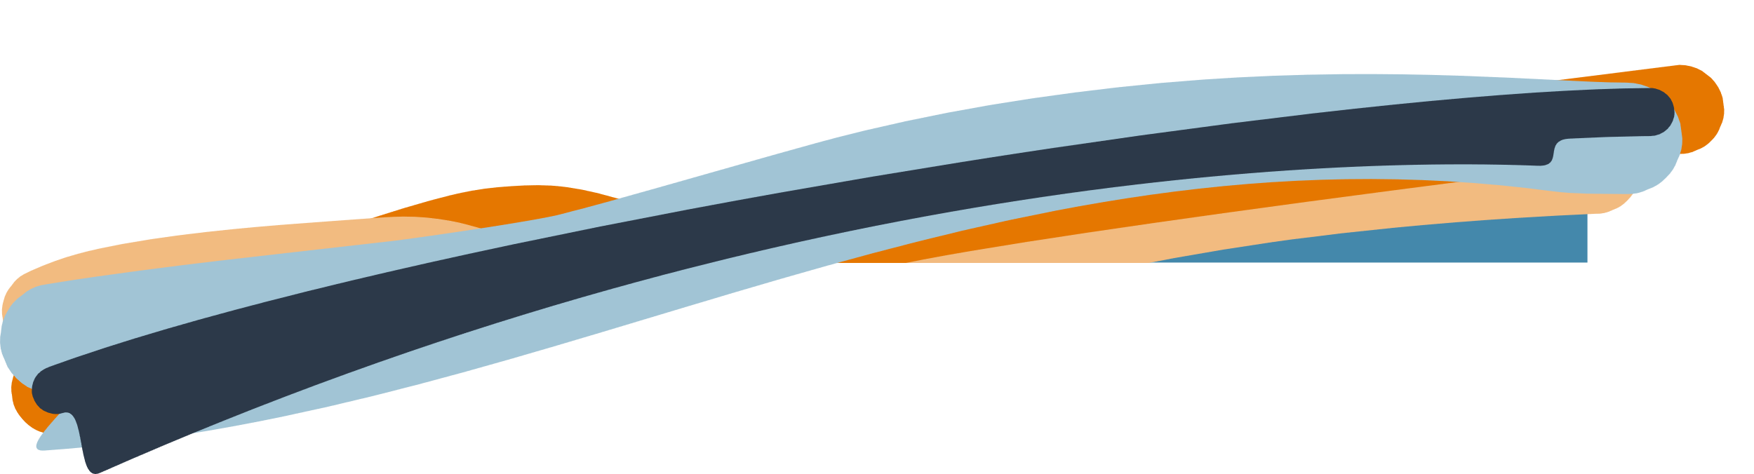
  - Safety Beyond Barriers: Diverse Family Perspectives on Violence and Disability
  - Project Executive Summary
Dr Liz Hudson, Dr Tess Altman, Madeleine Gay, Kira Duggan, Holly Helprin,
Jasmine (Jaz) MacDonald.
Children and Young People with Disability Australia (CYDA) and Australian Institute of Family Studies (AIFS)

March 2026

Lead organisation: Children and Young People with Disability Australia (CYDA)
Partner organisations: Australian Institute of Family Studies (AIFS)

Project team
- Dr Liz Hudson (She/her)|Project co-lead, CYDA Policy and Research Manager
- Dr Tess Altman (She/her)|Project co-lead, CYDA Policy and Research Co-ordinator
- Madeleine Gay (She/her)|Project support, CYDA Policy and Research Officer
Project team – Co-designers (5 members)|names withheld to protect privacy
Advisory Group Members (8 members):
- Kristin Diemer (she/her), Australia’s National Research Organisation for Women’s Safety
- Ashleigh Gould (she/her), Regional Disability Advocacy Service
- KerryAnn Stanley (she/her), First Peoples Disability Network
- Skye Kakoschke-Moore (she/her), Children and Young People with Disability Australia
- Liz Neville (she/her), Australian Institute of Family Studies
- Diana Piantedosi (she/they), Women with Disabilities Australia
- Sadikshya Dulal (she/her), National Ethnic Disability Alliance - replaced Samara Rodway (she/her)
- Katherine Marshall (they/she), Inclusive Rainbow Voices
- Partner Organisation project team members:
- Kira Duggan Partner lead, Australian Institute of Family Studies
- Holly Helprin, Partner organisation Australian Institute of Family Studies
- Jasmine (Jaz) MacDonald, Partner organisation Australian Institute of Family Studies replaced Sarah Quillinan

Period of project activity: 1 July 2025 to 1 April 2026
Contact person: Liz Hudson

Content notes
Distressing content includes mentions of family and domestic violence (FDV), trauma, abuse, bullying and ableism.

Contributors and acknowledgements
We acknowledge the contribution of our project team members including our partner organisations and Advisory Group members. We also acknowledge the facilitator of our codesign group and safety and well-being officer who both identify as having disability.
We especially acknowledge the work of our co-designers who brought their valuable lived experience and expertise to this project.
AI tools were not used in the research component of this project.
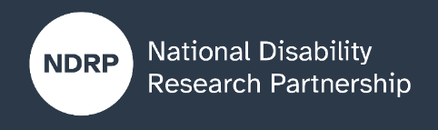
AI tools were used only for minor editing of this report to assist with improving conciseness and to support plain language. All key content was written by CYDA.
Use of AI is in accordance with CYDA policy.
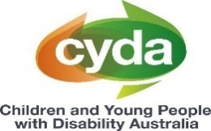

Contents

The issue we explored 5
Why this issue matters 5
What was co-designed 5
What were our key lessons from the co-design process 5
What the future research could achieve 6
What people with disability, policymakers, advocates, services and others need to know about this project 6

Co-designers recognised that no single project can capture all experiences. This work provides a strong foundation, but future research will need more time and resources to broaden participation and continue strengthening safe, inclusive approaches.

How to cite this summary
Hudson, L., & Altman, T. (2026). Safety Beyond Barriers: Diverse Family Perspectives on Violence and Disability. NDRP Final Project Executive Summary. Children and Young People with Disability Australia; Australian Institute of Family Studies. Published by the National Disability Research Partnership (NDRP).

The issue we explored
This project examined how children and young people with disability from diverse backgrounds experience family and domestic violence (FDV) in Australia.

Why this issue matters
Children and young people with disability experience higher rates of violence (FDV) than their peers without disability, yet their experiences are often overlooked in research, policy and practices. Most existing research focuses on the FDV experiences of people with disability of adults or on the perspectives of parents, caregivers and professionals. This means children and young people with disability are often not recognised as victim-survivors in their own right.
There are also challenges accessing the right support. Disability and FDV services often operate separately, making it difficult to receive coordinated, holistic care. These challenges are intensified for those experiencing multiple forms of disadvantage, including First Nations children, those from culturally and linguistically diverse backgrounds, LGBTQIA+ communities, those living in regional areas, or experiencing poverty. Without better research and coordination, these gaps will continue.

What was co-designed
This project brought together co-designers with lived experience of disability, FDV and diverse life experiences to shape a research proposal for a future study.
Co-designers were involved early through a preparatory session and participated in three co-design sessions over six months. They also had the opportunity to review the final proposal. This approach ensured the research reflects what matters most to people with lived experience and is grounded in real-world perspectives.

What were our key lessons from the co-design process

What worked well
Early and ongoing involvement of co-designers supported genuine collaboration, trust and inclusion. Providing a preparatory information session helped build shared understanding of research, ethics and FDV, supporting meaningful participation.
Clear roles, shared decision making and accessible materials created a strong foundation for engagement. Co-designers had final decision-making power, ensuring the research priorities were shaped by lived experience. Dedicated roles, including a lived experience facilitator and a Safety and Wellbeing Officer, were critical in creating a safe and respectful environment.

What was challenging and what could be improved
It was difficult to fully represent the diversity of experiences, particularly for people who are less often heard, such as those who are non-verbal or have intellectual disability. Some participants also held dual roles within the project, which created challenges around workload, boundaries and privacy.
Co-designers recognised that no single project can capture all experiences. This work provides a strong foundation, but future research will need more time and resources to broaden participation and continue strengthening safe, inclusive approaches.

What the future research could achieve
This project has laid important groundwork for future research that centres the voices of children and young people with disability, particularly those under 25 from diverse backgrounds.
Future research could strengthen evidence based on lived experience, improving understanding of how FDV affects children and young people with disability and challenging harmful assumptions and stereotypes. It could also inform more inclusive, accessible and responsive services - leading to more trusted, tailored support and better coordination between systems including disability, FDV and other diverse support settings.
Ultimately, this work aims to drive meaningful change in how systems respond to children and young people with disability.

What people with disability, policymakers, advocates, services and others need to know about this project
The most important messages for policy, practice and community includes:
- Children and young people with disability are victim-survivors in their own right
- Their voices must be heard and centred in research, policy and services
- Current systems are often disconnected and need to work better together
- Supports must be flexible, accessible and tailored to individual needs
- Different life experiences require different types of support
- Co-designed research is essential to creating solutions that work in practice.
Together, these insights reinforce the need for a more inclusive, coordinated and rights-based approach to supporting children and young people with disability experiencing violence.

Authorisation and endorsement
This Project Executive Summary has been reviewed and authorised by:
- Dr Liz Hudson (she/her) Policy and Research Manager, Children and Young People with Disability Australia |Project co-lead
- Dr Tess Altman (she/her) Policy and Research Co-ordinator, Children and Young People with Disability Australia |Project co-lead
- Skye Kakoschke-Moore (she/her) | CEO, Children and Young People with Disability Australia

Disclaimer
This Project Executive Summary represents the views of the project team and does not necessarily reflect the views of the National Disability Research Partnership (NDRP) or the Australian Government.

Acknowledgement of funding
This activity received grant funding from the Australian Government as an initiative under Australia’s Disability Strategy 2021–2031, delivered through the National Disability Research Partnership (NDRP).



CYDA will only use AI tools that support fairness, accessibility, and inclusion. AI should never replace human judgement in important decisions, especially in advocacy and work with young people with disability. AI-generated content must always be checked by a person before being used in external communications or decision-making. This includes ensuring that language aligns with CYDA’s Communications Guide, including inclusive, accessible, and strengths-based language, and is appropriate for an Australian audience, including spelling, terminology, and cultural context. AI content must also be checked for factual accuracy, as AI tools can produce errors or misleading information.

