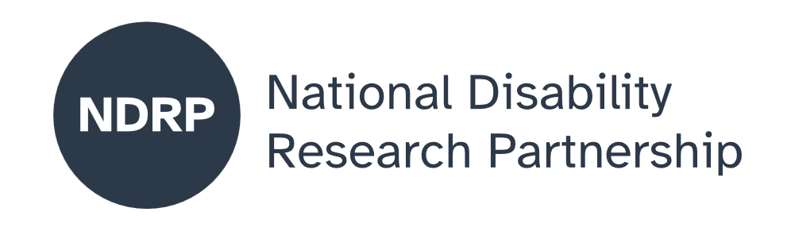
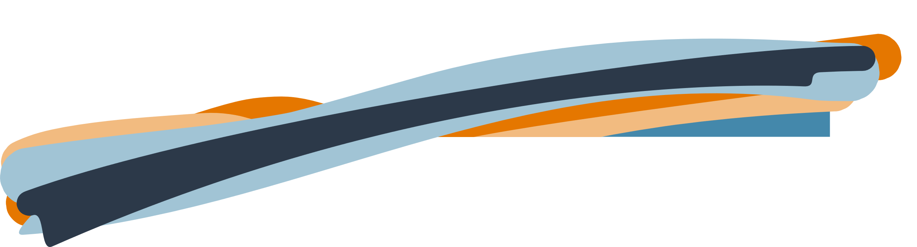
  - Safe in my own skin
  - Project Executive Summary
Prof Rachael McDonald, Mr. Caleb Rixon, Dr Melinda Smith, Ms. Caroline Bowditch, A/Prof Heather Feldner, A/Prof Elisabeth Lambert, Dr Hana Phillips, Prof John McCormick, Prof Jeni Paay, Prof Kim Vincs, Ms Paraskevi Triantis, Prof Simone Taffe, Ms. Claudia Bridge.

MedTechVic Hub, Swinburne University of Technology and Genyus Network

March 2026

Lead organisation: MedTechVic Hub, Swinburne University of Technology
Partner organisations: Genyus Network

Project team
This project was carried out collaboratively by neurodivergent community members, lived and living experience consultants, partner organisation representatives, and university-based researchers.
The list below includes people who contributed to the project, with their names and, where provided, organisational affiliations. Contributions included, but were not limited to, lived and living experience expertise, project administration, co-facilitation, advisory roles, research, and partner organisation collaboration.
Full name | Affiliation | Role
Prof Rachael McDonald | MedTechVic Hub, Swinburne University of Technology | Project Lead
Mr. Caleb Rixon | Genyus Network | Partner Organisation Lead
Dr Melinda Smith |  | Artist, Researcher and Disability-Led Creative Consultant
Ms. Caroline Bowditch |  | Disability Arts Leader and Cultural Equity Consultant
A/Prof Heather Feldner | CREATE | Associate Professor, Physical Therapy, Associate Director
A/Prof Elisabeth Lambert |  | Senior Research Fellow
Dr Hana Phillips |  | Research Fellow
Prof John McCormick | Centre for Transformative Media Technologies | Director
Prof Jeni Paay | Centre for Design Innovation | Director
Prof Kim Vincs |  | Senior Principal Research Fellow
Ms Paraskevi Triantis | MedTechVic Hub, Swinburne University of Technology | Design Coach
Prof Simone Taffe | Department of Communication Design | Associate Dean Research
Ms. Claudia Bridge | MedTechVic | Product development Officer

Period of project activity: August 2025 to February 2026
Contact person: Rachael McDonald, rachaelmcdonald@swin.edu.au

Content notes
This report discusses experiences of ableism, power imbalance, and psychosocial safety in healthcare settings. Readers may wish to take care when engaging with this content.

Contributors and acknowledgements
We acknowledge and thank the people and organisations who contributed their time, expertise and lived experience to this project listed above within the project team. We further acknowledge the contribution of all co‑researchers and collaborators who shared their knowledge, experiences and insights throughout the project
We also thank the MedTechVic administration team, Dr Joseph Braun, Lacey Zhang, Masha Perry and Rob McMahon, for their support with project coordination and logistics.

Use of AI tools
AI tools were used to support spelling, grammar and clarity during the preparation of this report. AI was not used to generate, substantiate or synthesise research findings, analysis or conclusions.

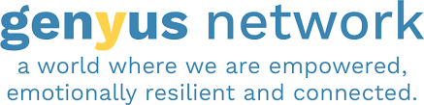

Contents

The issue we explored 5
Why this issue matters 5
What was co-designed 5
What were our key lessons from the co-design process 5
What the future research could achieve 6
What people with disability, policymakers, advocates, services and others need to know about this project 6

When people with lived experience had real authority, decisions changed in meaningful ways, including rejecting impairment simulation and reframing VR as a tool for relational learning.

How to cite this summary
McDonald, R., Rixon, C., Smith, M., Bowditch, C., Feldner, H., Lambert, E., McCormick, J., Paay, J., Vincs, K., Triantis, P., Taffe, S., Kramer, S. & Bridge, C. Phillips, H. (2026). Safe in my own skin. NDRP Final Project Executive Summary. MedTechVic Hub, Swinburne University of Technology. Published by the National Disability Research Partnership (NDRP).

The issue we explored
This project explored how people with lived experience of disability experience safety when accessing health and rehabilitation services. The project focused on psychosocial safety, whether people feel respected, believed, supported, and able to be themselves in healthcare settings. Many people with disabilities are often included in healthcare decision-making and research, but still experience ableism, power imbalances and limited influence over decisions. These experiences shape whether people feel safe to speak up, trust services, and remain engaged with care. This project looked at how safety is created in everyday interactions and how different ways of working together might address these challenges.

Why this issue matters
When people with disabilities feel unsafe in healthcare, they may hold back, disengage, or avoid care altogether. Psychosocial safety is about more than avoiding harm; it is about creating environments where people feel believed, respected, and in control of decisions about their own bodies and care.

What was co-designed
Feeling Safe in My Own Skin was a disability-led, co-designed project in which people with lived experience held real leadership, authorship, and decision-making authority, not just participation. The project produced a co-developed research proposal, directly informed by the lived experience and brought together co-researchers, clinicians, academics, and creative and VR practitioners to co-design:
- A shared understanding of psychosocial safety in healthcare.
- New ways of working that centre lived experience and shared power.
- Creative and embodied methods for exploring safety, identity, and relationships.
The co-design process was itself a key outcome that directly shaped the research proposal. Workshops, storytelling, movement, and creative practice shifted focus from deficit to capability and expression. Traditional methods focused on speed or standardisation were adapted or rejected, with accessibility, trust, and shared authority becoming priorities.

What were our key lessons from the co-design process
Psychosocial safety must be built and actively maintained. Trust, clear communication, and care are essential when working across different experiences, roles, and power dynamics. Time is a requirement for access, not a logistical issue; meaningful participation takes time to build trust and shared understanding. When people with lived experience had real authority, decisions changed in meaningful ways, including rejecting impairment simulation and reframing VR as a tool for relational learning. Creative and embodied approaches, where movement and interaction support communication, enabled people to express experiences difficult to put into words. For example, co-researchers used movement and nonverbal activities, such as describing an impactful experience without using words, to introduce themselves. This enabled co-researchers to explore and communicate experiences of safety and interaction in new ways.
- Psychosocial safety is foundational. Meaningful co-design and safe healthcare require people to feel respected, believed, and able to withdraw or disagree without penalty.
- Competence builds confidence. By supporting people with lived experience to develop language, skills, and authority, we fostered stronger participation and leadership. Importantly, we did not require or expect a standard path or outcome; varied approaches and results were respected.
- Lived experience is expertise. Recognising and enacting epistemic authority leads to better decision-making and increases the relevance and ethics of our work.
- Flat power structures matter. Shared leadership, explicit feedback, and repair mechanisms supported trust and better decisions.
- Creative and embodied practices reveal power. These approaches involved activities such as movement-based, metaphor-driven methods that accelerated trust-building and made abstract dynamics visible, often beyond what discussion alone can achieve.

What the future research could achieve
Future research could develop education and training to help healthcare providers create psychosocially safe environments and support new learning spaces where people with disability build confidence and strengthen their sense of control. There is strong potential to expand disability-led work using creative, immersive technologies and to develop practical measures of safety, trust, and shared decision-making — turning these ideas into tools and approaches that improve everyday healthcare.

What people with disability, policymakers, advocates, services and others need to know about this project
This project shows that psychosocial safety is built through everyday interactions, shared power, and genuine relationships, and that when people with lived experience have real authority, outcomes improve. For policymakers and services, this means investing in disability-led approaches, recognising time as an access requirement, and supporting co-design that goes beyond consultation. For people with disability and advocates: lived experience is expertise and should shape how healthcare is designed and delivered.

Authorisation and endorsement
This Project Executive Summary has been reviewed and authorised by:
- Professor Rachael McDonald, Chief Investigator
- Caleb Rixon, Partner Organisation Lead (Genysus)

Disclaimer
This Project Executive Summary represents the views of the project team and does not necessarily reflect the views of the National Disability Research Partnership (NDRP) or the Australian Government.

Acknowledgement of funding
This activity received grant funding from the Australian Government as an initiative under Australia’s Disability Strategy 2021–2031, delivered through the National Disability Research Partnership (NDRP).



