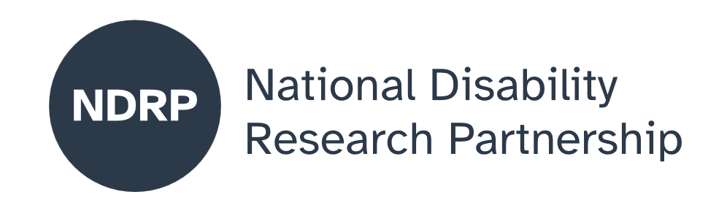

  - Hidden in plain sight: Culturally responsive continence care for First Nations women with disability
  - Project Executive Summary
Jody Barney, Deaf Indigenous Community Consultancy, Alexandra Devine, Marie Huska, The University of Melbourne, Sue Blinman, Continence Nurses Australia, Lexine LS Solomon, Stacey Briggs, Independent First Nations co-researchers
June 2026

Lead organisation: Deaf Indigenous Community Consultancy
Partner organisations The University of Melbourne, Continence Nurses Australia

Project team
- Project lead: Jody Barney, Deaf Indigenous Community Consultancy
- Co-investigators: Alexandra Devine, Marie Huska, The University of Melbourne, Sue Blinman, Continence Nurses Australia
- Lexine LS Solomon, Stacey Briggs, Independent First Nations co-researchers
Period of project activity: July 2025 to May 2026
Contact person: Jody Barney

Acknowledgement
Deaf Indigenous Community Consultancy and partners wish to acknowledge the traditional owners of the lands on which the co-design project established itself. That of the Yorta Yorta/Bangarang peoples in Shepparton and the Wurundjeri people of the Kulin Nation. Paying respects to their Elders, past and present. We also acknowledge the First Nations women who contributed to this co-design process and shared their wisdom, knowledge and networks to ensure proper engagement and cultural protocols were adhered.
Content notes
We wish to share that this report will have at times confronting and culturally sensitive information and materials. We acknowledge that these comments, conversations and evidence identifies that this topic is truly “hidden” in many First Nations communities, not just in this region. We hope that the content shared with you today of our engagement and co-design process allows you to reflect and consider the importance of true co-design processes and relationships that are required to ensure all parties and First Nations women with Disabilities have safe and culturally safe access to continence care.
Contributors
We sincerely thank the many people who supported this project, with special thanks to Leah Lindrea Morrison (Aboriginal Health and Community Connector, Shepparton), Jason King (University of Melbourne), Layla Fernandes Ranson (Continence Health Australia), Andrea Mason, Kim McRae (Ngaanyatjarra Pitjantjatjara Yankunytjatjara Women’s Council (NPYWC)), Patrick McGee (Victorian Aboriginal Community Controlled Health Organisation).
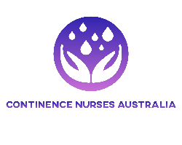
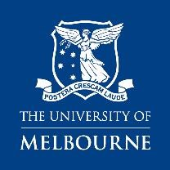
Deaf Indigenous Community Consulting Logo ©™2026

Contents

The issue we explored 4
Why this issue matters 4
What was co-designed 4
What were our key lessons from the co-design process 4
What the future research could achieve 4
What people with disability, policymakers, advocates, services and others need to know about this project 5

Awareness and advocacy about continence care and safety for First Nations women with disability remain scarce, undermining the co-creation of culturally responsive training, services and supports that help women stay safe, live more independently and remain on Country and/or with family.

How to cite this summary
Barney J., Devine A., Huska M., Blinman S., Solomon LSL. (2026). Hidden in plain sight: Culturally responsive continence care for First Nations women with disability. Project Executive Summary. Deaf Indigenous Community Consultancy, The University of Melbourne, Continence Nurses Australia. Published by the National Disability Research Partnership (NDRP).

The issue we explored
Incontinence affects one in three people with disability. It is often a hidden issue and can be hard for individuals and families to talk about or access required care and support. First Nations women with disability are more likely to be impacted, given higher rates of disability and conditions that contribute to incontinence (e.g. pregnancy, diabetes, kidney disease, urinary tract infections). Managing continence can be particularly difficult within First Nations communities, especially in rural and remote areas, due to insufficient access to culturally safe continence care, disability and health information, services and supports, alongside limited transport, financial constraints and disrupted accesses to water, sanitation, and continence care products.

Why this issue matters

Insufficient access to quality continence care can place significant stress on individuals, families and paid carers and can lead to harmful practices (like restricting fluids, using unsuitable products or isolating people), loss of dignity and autonomy, carer burnout, and increased risk of neglect or abuse. There are currently no continence resources tailored for First Nations women with disability and their support systems. Greater understanding of lived experience of disability, continence and safety for First Nations women, families, communities and service providers is needed. Our project sought to progress this understanding by working collaboratively with First Nations communities and policy and practice partners to explore the issue and co-design a culturally aligned and inclusive research proposal to address this gap.

What was co-designed
This project was First Nations and disability-led and bought together researchers with and without disability, continence and disability policy and practice partners and people with lived experience of continence needs. The project team worked closely with community and women with disability and their kinship carers to co-design our Ways of Working and approaches to engaging in what is a very “hidden” and sensitive topic. Through these processes, we developed more understanding about the experiences of women, their kinship carers, continence and disability workers in relation to continence and safety. Drawing on this understanding, the team co-designed a research protocol and future funding application to progress our research.

What were our key lessons from the co-design process
Throughout the project, we had a strong focus on knowledge sharing and support for team members and the women we worked with in community. For example, the project lead listened to women and kinship carers about their experiences whilst providing information on practical strategies to enhance continence care within the home and discussing what additional supports may be available to support women and kinship carers. Not only was this critical for the co-design process, but it opened up spaces for safe dialogue that helped women and families feel more empowered to start advocating for better supports. These process and outcomes, however, were only possible within the project time frame because of the existing and trusted relationships held by the Project lead and First Nations members of the team. Cultural protocol also meant that sensitive yarnings with community members did not involve the non-Indigenous team members. As such, our Ways of Working needed to remain flexible to ensure that all team members could contribute to knowledge sharing and continue to draw on shared knowledge to inform the co-design of our protocol for the next stage of research.

What the future research could achieve
Awareness and advocacy about continence care and safety for First Nations women with disability remain scarce, undermining the co-creation of culturally responsive training, services and supports that help women stay safe, live more independently and remain on Country and/or with family. Future research must address these gaps for people who need continence care - whether they live in urban, rural or remote areas, in community, or within disability and aged care settings - and must be implemented in genuine partnership with community so local knowledge and lived experience shape both local solutions and broader policy and practice. Emerging evidence must drive action that strengthens the capacity of individuals, families, continence providers and the disability workforce to deliver culturally responsive continence care, so that women with disability and their families can receive the support they need to live safely at home and on their lands wherever possible. Where remaining at home is not achievable, care must be provided in ways that maximise dignity, autonomy, independence and safety.

What people with disability, policymakers, advocates, services and others need to know about this project
The issue of continence and safety for First Nations women with disabilities is commonly overlooked and “hidden”. Caring arrangements for people experiencing quite complex chronic illness, disability and continence needs have shifted in communities and a lot of ownership of responsibility is falling on younger daughters and nieces, who often have to forego socio-economic participation to navigate care. Insufficient access to knowledge and support for individuals and carers means that continence care needs are often not identified or addressed until circumstances escalate to the point of people having to leave home and enter hospital, disability or aged care services: a process that causes dislocation, disruption of relationships, distress and distrust. However, awareness, early intervention and improved supports can help prevent declines in health and also prevent breakdowns in relationships and trust that impact on the safety of the women with disabilities living with continence care concerns.
Co-designed research that centres knowledge sharing is urgently needed to empower every level of the "care tree" and to lay the roots for culturally responsive continence care models. First Nations women with disabilities and their kinship carers are both seeking knowledge and hold vital lived experience to guide better practice. Strengthening the capacity of continence providers and disability workers to deliver culturally safe, evidence-informed care is central to this work. Equally important is collaborative engagement between diverse First Nations people and non-Indigenous stakeholders across health, continence, disability and aged care policy and practice, so women with disabilities can receive the continence care they need to be safe and to live well.

Authorisation and endorsement
This Project Executive Summary has been drafted, reviewed and authorised by, Jody Barney, Project lead, Director of Deaf Indigenous Community Consultancy.

Disclaimer
This Project Executive Summary represents the views of the project team and does not necessarily reflect the views of the National Disability Research Partnership (NDRP) or the Australian Government.

Acknowledgement of funding
This activity received grant funding from the Australian Government as an initiative under Australia’s Disability Strategy 2021–2031, delivered through the National Disability Research Partnership (NDRP).


