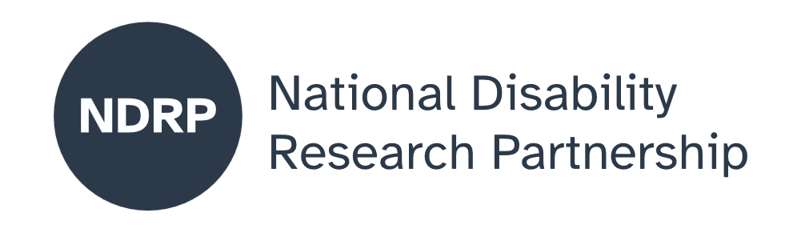
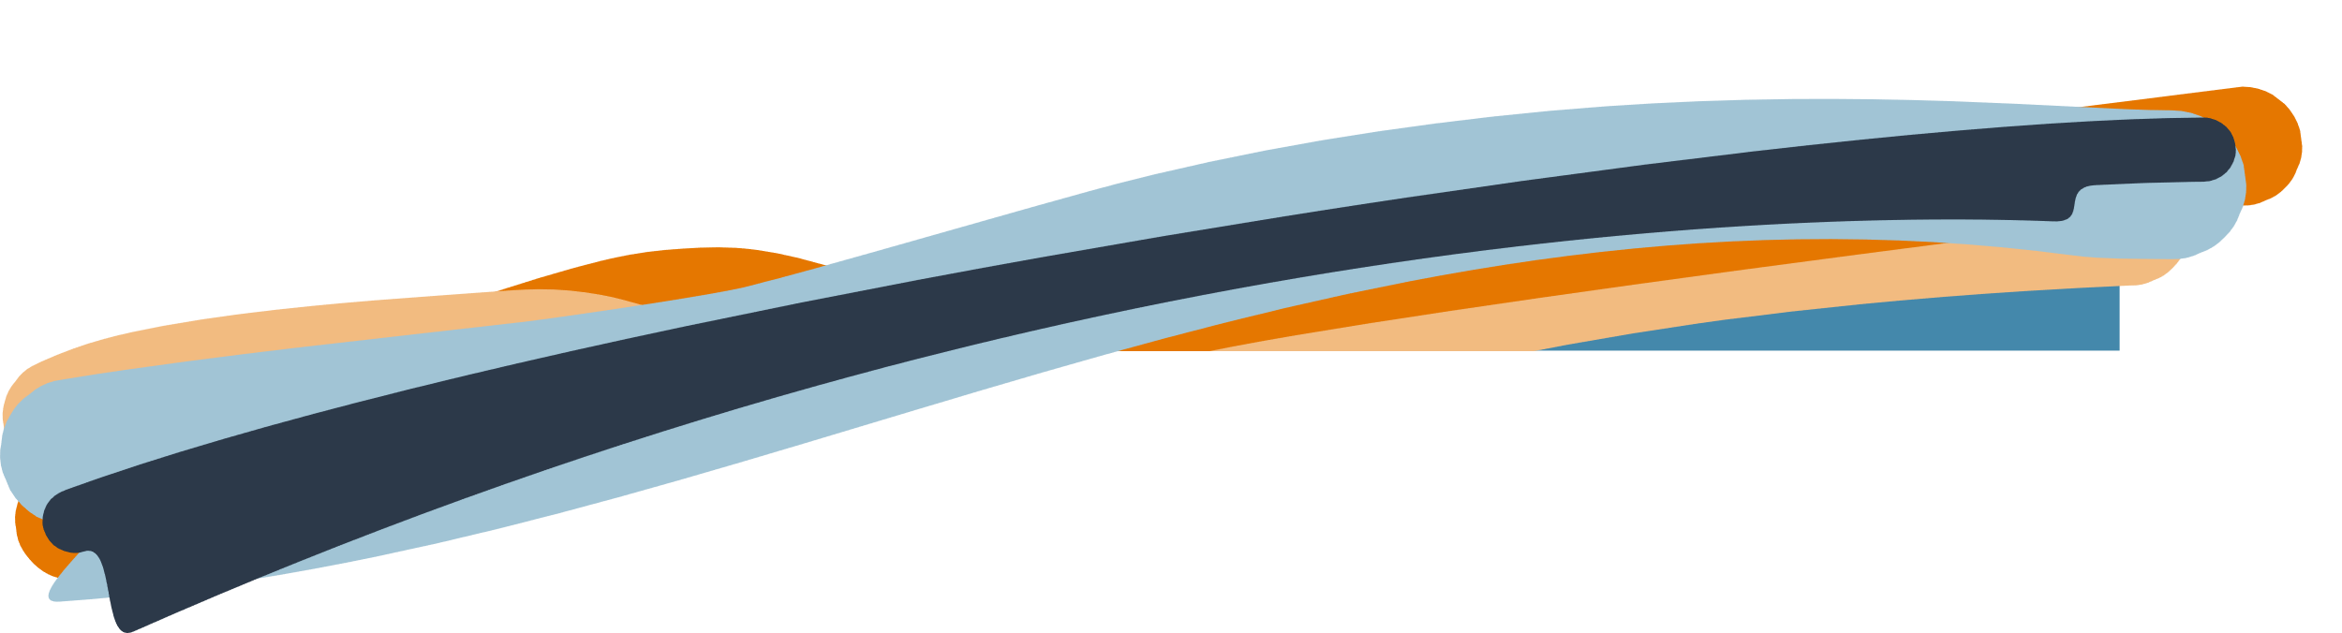
  - Safe-MEALS: Safe food, Enjoyable Meals, Advocacy and Lived Experiences
  - Project Executive Summary
Professor Bronwyn Hemsley, The University of Technology Sydney; Fiona Given, The University of Technology Sydney, Associate Professor Deborah Debono, The University of Technology Sydney; Janice O’Connor, Partner, Onemda; Dr Anneke Jurgens, Partner, Melba Support Services; Stacey Baldac, Partner, Speech Pathology Australia; Dr Jeff Chan, Partner, consultant.

March 2026

Lead organisation: The University of Technology Sydney
Partner organisations: Melba Support Services, Onemda, Speech Pathology Australia

Project team
This project was carried out collaboratively by neurodivergent community members, lived and living experience consultants, partner organisation representatives, and university-based researchers.
The list below includes people who contributed to the project, with their names and, where provided, organisational affiliations. Contributions included, but were not limited to, lived and living experience expertise, project administration, co-facilitation, advisory roles, research, and partner organisation collaboration.
Full name | Affiliation | Role
Professor Bronwyn Hemsley | The University of Technology Sydney | Chief Investigator
Fiona Given | The University of Technology Sydney | Chief Investigator
Associate Professor Deborah Debono | The University of Technology Sydney | Chief Investigator
Janice O’Connor | Onemda | Partner
Dr Anneke Jurgens | Melba Support Services | Partner
Stacey Baldac | Speech Pathology Australia | Partner
Dr Jeff Chan | Consultant | Partner

Period of project activity: August 2025 to March 2026
Contact person: Professor Bronwyn Hemsley

Contributors and acknowledgements
We acknowledge the investigators, partners, consultants, employees, and participants in this project including people with disability, family members, and direct support workers. AI tools were used in the process of workshopping in transcribing post-it notes into text and in extracting information from death reports of people who have choked on food.

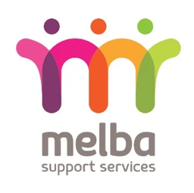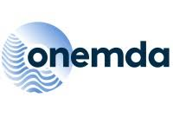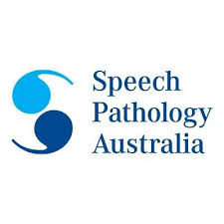

Contents

The issue we explored 4
Why this issue matters 4
What was co-designed 4
What were our key lessons from the co-design process 4
What the future research could achieve 5
What people with disability, policymakers, advocates, services and others need to know about this project 5

The time we spent in co-design increased the “real life” aspects of the research. Bringing people together to discuss the issues gave us a clearer understanding of how complex the issues are.

How to cite this summary
Hemsley, B., & Given, F. (2026). Safe-MEALS: SAfe Food, Enjoyable Meals, Advocacy and Lived Experiences. Project executive summary. Published by the National Disability Research Partnership (NDRP).

The issue we explored
We explored the safety of people with disability and dysphagia (swallowing difficulty) during mealtimes. People with swallowing difficulty who need support from others during meals are at great risk of choking on food or developing aspiration pneumonia. This can result in preventable, serious illness or death. We wanted to know what things will help to keep people with disability safe at mealtimes. We also co-designed a larger project addressing this problem for all Australians with swallowing difficulties.

Why this issue matters
Choking on food and aspiration pneumonia are among the most common causes of death for people with disability in supported accommodation. This issue matters as food is vital to life, and swallowing difficulties can impact access to food, health, nutrition, and participation in society. Food and mealtimes are very important parts of our culture. People with swallowing difficulties need good information for their support workers. They need mealtime management plans that help to ensure that they can be safe at mealtimes and still enjoy their food. Mealtime decisions are complex, when so many issues affect food preparation and mealtime assistance.

What was co-designed
Our project team worked together on all aspects of the project, in meetings online and in person. We co-designed many parts of the project:
- research tools to be used in collecting data;
- the ethics application and all attachments for the University ethics committee and partner organization approval;
- all questions and protocols for a survey of direct support workers, interviews with parents and staff, and focus groups with people with disability, support workers, and family members;
- a new tool for understanding ‘safety incidents’ in incident reporting databases in two disability organisations;
- a new tool for examining the content of coroner reports on the deaths of people with disability that related to choking on food; and
- a larger Australia-wide project involving a survey of support workers, interviews and focus groups with people with disability, family members, health professionals, and managers.

What were our key lessons from the co-design process
The time we spent in co-design increased the “real life” aspects of the research. Bringing people together to discuss the issues gave us a clearer understanding of how complex the issues are. One of the most helpful things was to have meetings online as well as meetings in person. Our project team travelled to meet with the partner organisations for two days. This interstate travel was so valuable in showing how important the topic was and giving respect to people who are not traditionally included in research at universities. We also co-designed our research tools and saw the benefits of using Generative AI to reduce the time spent on manual tasks involving typing and increase the time available for consultation..

What the future research could achieve
We co-designed future research with a national scale, to scale-up the investigation and capture greater diversity and number of people with disability to be included in the research. Meeting NDIS Practice Standards and Quality Indicators in relation to dysphagia and mealtime assistance relies upon more than training and awareness, as decisions about meals are made at the individual level, and vary from person to person.

What people with disability, policymakers, advocates, services and others need to know about this project
Our project was the first of its kind to take a co-design approach to mealtime management research exploring the lived experiences of people most affected by swallowing disability and choking incidents. Efforts should be made not only to reduce risk of choking, but to prevent choking. To do so, it is important to identify risk of choking and to report any incidents at mealtimes that indicate increased risk of choking and actions to be implemented to prevent future choking or mealtime-related safety incidents. Disability services need to maintain safety incident databases, including near miss incidents (where the person recovers from choking) to learn from each incident to prevent future choking on food, and this should be reportable to governing bodies. Co-design of incident databases to include consideration of the organisation’s policies, staff views on how to increase the reporting of incidents, and supporting a positive culture of incident-reporting is important.

Authorisation and endorsement
This Project Executive Summary has been reviewed and authorised by Bronwyn Hemsley, Chief Investigator; and Fiona Given, Co-researcher representative

Disclaimer
This Project Executive Summary represents the views of the project team and does not necessarily reflect the views of the National Disability Research Partnership (NDRP) or the Australian Government.

Acknowledgement of funding
This activity received grant funding from the Australian Government as an initiative under Australia’s Disability Strategy 2021–2031, delivered through the National Disability Research Partnership (NDRP).



