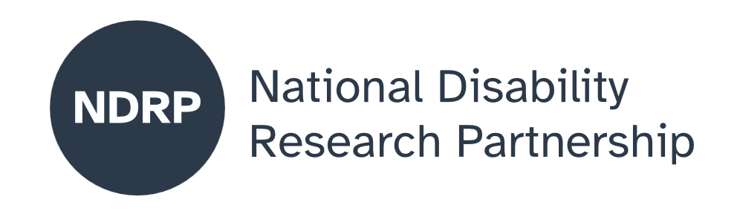

  - Exploring the mobility safety concerns of Australians with deafblindness
  - Project Executive Summary
Dr Meredith Prain, Dr Sue Silveira, Associate Professor Kathleen Tait, Heather Lawson, Stephen Hallinan, Melinda Carter, Lisa Chen.
Able Australia, NextSense Institute, Macquarie University, Deafblind Victoria, Hunter Deafblind Connect, Deafblind West Australians
May 2026

Lead organisation: Able Australia
Partner organisations: NextSense Institute, Macquarie University, Deafblind Victoria, Hunter Deafblind Connect, Deafblind West Australians

Project team
Full name | Affiliation | Role
Dr Meredith Prain | Able Australia | Project Manager
Dr Sue Silveira | Next Sense | Researcher and steering committee member
Associate Professor Kathleen Tait | Macquarie University | Researcher and steering committee member
Heather Lawson | Deafblind Victoria | Researcher and steering committee member
Stephen Hallinan | Hunter Deafblind Connect | Researcher and steering committee member
Melinda Carter | Deafblind West Australians | Researcher and steering committee member
Lisa Chen | Hunter Deafblind Connect | Researcher and steering committee member

Period of project activity: July 2025 to May 2026
Contact person: Dr Meredith Pain

Contributors and acknowledgements
We acknowledge all people and organisations who contributed to the project, including partner organisations, the deafblind participants, Auslan interpreters, and Communication Guides.

 |  | 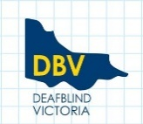 |  | 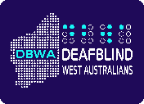

Contents

Why this matters to people with deafblindness 4
What was co-designed 4
What were our key lessons from the co-design process 5

Key lesson:
…additional time and effort required to process information using assistive technology or human communication supports including Auslan interpreters, when projects have tight deadlines.

How to cite this summary
Prain, M., Silveira, S., Tait, K., Lawson, H., Hallinan, S., Carter, M., Chen. L. (2026). Exploring the mobility safety concerns of Australians with deafblindness – Project executive summary. Able Australia; NextSense Institute; Macquarie University; Deafblind Victoria; Hunter Deafblind Connect; Deafblind West Australians. Published by the National Disability Research Partnership (NDRP).

Why this matters to people with deafblindness
Deafblindness is a unique and complex disability which impacts all aspects of daily life, in particular communication, orientation and mobility, and access to information. Recent work to develop International Classification of Functioning, Disability and Health Core Sets for deafblindness highlighted mobility as a key challenge. Orientation and mobility was particularly highlighted as a concern by individuals with deafblindness internationally. When State based peer led support and advocacy groups were contacted to ask if they would like to partner to undertake the project, all agreed this is an important topic to Australians with deafblindness.

What was co-designed
This project aimed to co-design:
- A process to determine research priorities in the area of mobility safety with people with deafblindness
- A priority research question to be addressed
- A process to address the priority research question
Three people with research backgrounds partnered with four people with deafblindness (the deafblind co-researchers) with varying degrees of experience in research and met online with both visual and tactile Auslan interpreters to determine research processes and questions.
Ethics approval for the project was gained through Macquarie University.
The four deafblind co-researchers sent project information to members of their State based organisations, inviting the members to participate in the project until consent to participate had been received from eight people with deafblindness in each of the three States.
Three of the deafblind co-researchers co-facilitated focus groups in their State in Melbourne, Perth and Newcastle.
The lead researcher on the project analysed the data from the focus groups using thematic analysis (Braun and Clark, 2006).
The key themes which the analysis of the focus group data generated were:
- Structural / environmental issues (e.g. lacking or broken traffic lights, hazards in pathways, lack of accessible signage)
- Issues with vehicles (e.g. vehicles blocking pathway, vehicles illegally parked)
- Public transport (e.g. accessible public transport information particularly when there are changes)
- Strategies for safe mobility (e.g. planning, using technologies, orientation and mobility specialist involvement)
- Human assistance, positive and negative experiences,(e.g. CommGuides, public transport staff, taxi and uber drivers)
The full analysis was sent to the full project team and the team met to discuss the analysis. The four deafblind co-researchers agreed that the analysis reflected what was raised at the focus groups, but noted the data needed to be presented differently for screen reader users. The full team also discussed how best to determine the priority research questions from the focus group data.

The team considered, from the focus group data, what research questions might:
- lead to real world outcomes?
- be achievable in a 12 month project period?
- contribute to improved outcomes for deafblind Australians nationally?
While structural and environmental issues were the most discussed concerns in the focus groups, it was agreed that there are already standards and mechanisms for reporting these issues. Human assistance, another key theme highlighted the general lack of awareness of deafblindness among service providers and fellow pedestrians alike.
General and targeted awareness raising programs were discussed, and the team ultimately agreed the people who can have the biggest impact on addressing safe mobility of Australians with deafblindness, and consistent with the issues raised in the focus groups, were Communication Guides, Orientation and Mobility Specialists, and public transport staff. leading to the research questions:
- What do Orientation and Mobility Specialists need to know to better work with deafblind people?
- What do CommGuides need to learn about safe guiding?
- How can public transport providers better meet the needs of deafblind travellers?
These three questions were sent to the 21 focus group participants, who were asked to select their top two preferred questions with – What do Orientation and Mobility Specialists need to know to work with deafblind people? being the most popular research question.
The project team met for the final time to approve the plain English report and agree upon a way to address the proposed research question. The full project team agreed they would like to continue to work together and apply for funding to address the co-designed research question and how this might be achieved through a series of national world café events involving all key stakeholders including:
- Australians with deafblindness
- Family members
- Orientation and Mobility Specialists
- Communication Guides
Representatives from key organisations, such as the University of New South Wales who train Orientation and Mobility Specialists and the Orientation and Mobility Association of Australia.

What were our key lessons from the co-design process
With regard to co-design with deafblind people, many structural barriers make the inclusion of people with deafblindness as co-researchers challenging. These barriers include:
- Reduced educational opportunities
- Reduced employment opportunities
- Access to both assistive technology and the training in how to use it
- Access to communication supports including Auslan interpreters skilled in deafblind communication methods
- The additional time and effort required to process information using assistive technology or human communication supports including Auslan interpreters, when projects have tight deadlines.
To address these systemic barriers, it is recommended that organisations funding research which genuinely involves deafblind people in decision making processes:
- Allows for a separate pool of funding for communication access support over and above the funding allocated to undertake the research
- Allows additional time, or expect fewer outputs within the project deadlines
- Provides educational opportunities for learning about research processes

Disclaimer
This Project Executive Summary represents the views of the project team and does not necessarily reflect the views of the National Disability Research Partnership (NDRP) or the Australian Government.

Acknowledgement of funding
This activity received grant funding from the Australian Government as an initiative under Australia’s Disability Strategy 2021–2031, delivered through the National Disability Research Partnership (NDRP).



